|  |
| --- |
| Hospital Management System |
| Software Engineering and information System Design Sessional |
|  |
|  |



**Software Engineering and Information System Design Sessional**

**Report on**

**HOSPITAL MANAGEMENT SYSTEM**

Supervised By:

**Dr. Tanzima Hashem**

**Assistant Professor CSE , BUET**

**Sajjadur Rahman**

**Lecturer CSE, BUET**

**Johra Muhammad Moosa**

**Lecturer CSE, BUET**

By

Group : 5

Group members:

1005011  
1005016  
1005019  
1005021  
1005024

Contents

1 Overview of the Project 5

1.1 Introduction: 5

1.2 Project Overview 5

1.3 Aims/ Goals of the Project: 6

1.4 Motivation for the Proposed System 7

2 Existing System Study and Scope Definition 8

2.1 Introduction 8

2.2 Existing System Analysis 8

2.3 Problem Analysis 8

2.4 Scope of Implementation 9

3.Requirement Analysis and Feasibility Study 10

3.1 Introduction 10

3.2 Requirement Analysis 10

3.2.1 Stakeholder identification 10

3.2.2 Requirement discovery 11

3.2.1 Requirement Table 11

3.3 Feasibility Study 14

3.3.1 Operational Feasibility: 14

3.3.2 Technical Feasibility: 15

3.3.3 Economic Feasibility: 16

3.3.4 Cultural Feasibility 18

Chapter 4 : PROPOSED SYSTEM Design 19

4.1 Introduction 19

4.2 Subsystems: 19

4.3 Actors 19

4.4 Use case diagram 20

4.4.1 Registration System 20

4.4.2 Patient Management System 24

4.4.3 Employee Management System: 31

4.4.4. Billing System: 38

4.4.5 Scheduling System 41

4.5 Fishbone Diagram 44

4.6 Data Flow Diagram 47

4.6.1 Data Flow Diagram of Registration Subsystem 47

4.6.2 Data Flow Diagram of Patient Management Subsystem 48

4.6.3 Data Flow Diagram of Employee Management Subsystem 49

4.5.4 Data Flow Diagram of Billing Subsystem 50

Data Flow Diagram of Scheduling Subsystem 51

4.6 System Design 52

4.6.1 Class Diagram: 52

4.6.2 Collaboration Diagram: 57

4.6 Process Design: 66

4.6.1 Sequence Diagram: 66

4.6.2 Statechart Diagram: 83

4.6.3 Activity Diagram: 85

5 Database DESIGN 96

5.1 Introduction: 96

5.2 ERD Diagram: 98

5.3 Relational Schema: 109

5.4 Triggers 119

5.5 Procedures 123

6 Graphical User Interface Design: 130

6.1 Introduction 130

6.2 User Interface for Patient 131

6.3 User Interface for Doctor 133

6.4 User Interface for Admin 135

6.5 User Interface for Receptionist 137

6.6 User Interface for Data Entry Manager 139

6.7 User Interface for Human Resource Officer 140

6.8 User Interface for Clerk 141

7. Project Management 143

7.1 Project Phases and Activities 143

7.2 Project Scheduling Phases 144

7.2.1 Task Duration & Dependency List 144

7.2.2 Activity Network 145

7.2.3 Pert Chart 146

7.3 Cost Benefit Analysis: 147

7.4 Risk Management 151

## 1 Overview of the Project

## 1.1 Introduction:

Human Body is a very complex and sophisticated structure and comprises of millions of

functions. All these complicated functions have been understood by man him, part-by part their research and experiments. As science and technology progressed, medicine became an integral part of the research. Gradually, medical science became an entirely new branch of science. As of today, the Health Sector comprises of Medical institutions i.e. Hospitals, HOSPITALs etc. research and development institutions and medical colleges. Thus the Health sector aims at providing the best medical facilities to the common man.

Medical Institutions in Bangladesh

Still being a developing nation India has seen a tremendous growth of the Health sector

in the field of research as well as in the field of development of numerous large and small scale Hospital institutions still lacking in inter-structure facilities. Government of Bangladesh has still aimed at providing medical facilities by establishing hospital. The basic working of various hospitals in Bangladesh is still on paper as compared to hospitals in European countries where computers have been put in to assist the hospital personals their work. The concept of automation of the administration and management of hospital is now being implemented in Bangladesh also, with large hospitals like APPOLO ,SQUARE , UNITED having automated their existing system.

1.2 Project Overview:

Our project is based on the above concept i.e. automation of Administration and

Management of Hospital. The project has been developed keeping in-view the following

aspects: -

(i) Working environment of the Hospital.

(ii) The thought-process and attitude of Bangladeshi people.

(iii) The literacy rate of Bangladesh.

(iv) The Existing system, being used in the majority of Hospitals.

(v) The availability of Infra-structural facilities likes finance, skilled personals, and

working environment.

In this project we have tried to Automate the Patient Management part and Employee Management part of the Hospital. We also automated the Billing system and Auto Schedule System of the Hospital.

The project maintains four levels of users:-

* Doctor
* Patient
* Admin
* Employee

Main facilities available in this project are:-

* Maintaining records of indoor/outdoor patients.
* An account for every user.
* Maintaining patient’s prescription and medicine details.
* Providing billing details for indoor/outdoor patients.
* Auto Schedule Employee Duties.
* User or Administrator can search a patient’s record by his/her name or their registration date.

## 1.3 Aims/ Goals of the Project:

1. Planned approach towards working:-

The working in the organization will be well planned and organized. The data will be stored properly in data stores, which will help in retrieval of information as well as its storage.

2. Accuracy: -

The level of accuracy in the proposed system will be higher. All operation would be done correctly and it ensures that whatever information is coming from the center is accurate.

3. Reliability: -

The reliability of the proposed system will be high due to the above stated reasons. The reason for the increased reliability of the system is that now there would be proper storage of information.

4. No Redundancy: -

In the proposed system utmost care would be that no information is repeated anywhere, in storage or otherwise. This would assure economic use of storage space and consistency in the data stored.

5. Immediate retrieval of information: -

The main objective of proposed system is to provide for a quick and efficient retrieval of information. Any type of information would be available whenever the user requires.

6. Immediate storage of information: -

In manual system there are many problems to store the largest amount of information.

7. Easy to Operate: -

The system should be easy to operate and should be such that it can be developed within a short period of time and fit in the limited budget of the user.

1.4 Motivation for the Proposed System:

1. Better service for Patients.
2. Reduce paperwork of the hospital.
3. Reduce cost of the hospital.
4. Better treatment for patients.
5. Improve accuracy of the existing system.

2 Existing System Study and Scope Definition:

2.1 Introduction:

Some hospitals are partly automated; especially the accounting system is automated in many hospitals. After studying the existing system , we decided not to redo things which are already done and so accounting part of the hospital is out of the scope of this project.

2.2 Existing System Analysis:

1. Patient Registration is manual:

There is no patient account. Patient cannot view his old records at home. To be registered at hospital the patient has to go through a long process which is a wastage of time.

1. No Medical History of Patients:

Hospital don’t keep track of medical history of patients. Patients has to bring old records with them to visit the doctor again.

1. Employee Registration is manual:

Employee management is manual. No account is created for employee.

1. Scheduling Employee Duty is manual:

Creating and distributing schedule is manual and so prone to errors.

1. Accounting system automated:

Accounting department is automated and functional. And our project will be compatible with existing automated system.

2.3 Problem Analysis:

In Existing public medical system, there occur a lot of problems as well as wasting a lot of time. From those 2 scenarios we can easily identify some preliminary problems.

* Manual registration system is a lengthy procedure 🡪 wastage of time and patience standing in long queue and crowd
* Disordered and undeclared time schedule 🡪patients are not concerned of doctor‘s availability.
* Sometimes long human queue is not maintained properly.
* Sometimes cunning brokers cheat people coming from far distance.
* Some Private medical offers better service in huge costs🡪a nightmare for an ordinary people of our country.
* For proper treatment doctors need past records of the patients .In most cases, patients just lost their medical reports, prescriptions, how long they continued medicine etc.
* Patients coming from far distance face difficulties much. Perfectly telling about intermediate medication becomes harder.
* Patients have to pay extra money for same medical reports they did before.
* Sudden leave of Employee makes a nightmare in rescheduling employees of the hospital.

2.4 Scope of Implementation:

This parts are within the scope of our implementation:

* 1. Patient Registration
  2. Patient Management
  3. Employee Management
  4. Bill collection
  5. Auto Scheduling

We choose not to implement this prts :

* + 1. Medicnie Store management
    2. Pathology lab management
    3. Accounting

So this is the scope of our implementation.

# 3.Requirement Analysis and Feasibility Study

## 3.1 Introduction

According to **IEE Requirements Analysis** denotes to:

* A condition of capability needed by the user to solve a problem or achieve an objective.
* A condition or capability that must be meet or possessed by a system to satisfy a contract, standard, specification, or other formally imposed document.

From analysis of the existing system, and consulting with the stakeholders we find out many requirements that they need and that might help to improve the functionality of the whole system to a great extent. This chapter deals with those requirements in details.

## 3.2 Requirement Analysis

### 3.2.1 Stakeholder identification

For indentifying the requirements first we indentified the stakeholders of the system. They are:

1. Doctors
2. Employees
3. Patient
4. Administrator
5. Receptionist
6. Human Resource Officer
7. Data Entry Manager
8. CLerk

The requirement of the stakeholders is discussed in details in the following sections.

### 3.2.2 Requirement discovery

By consulting with our stakeholders we indentified their requirements. Besides we also find out some problems in the existing system. They are discussed below:

### 3.2.1 Requirement Table

The requirements described in the previous section are listed below in a tabular from with their corresponding dependencies, required technologies, priorities, stakeholders and advantage, disadvantages.

|  |  |  |  |  |  |  |  |
| --- | --- | --- | --- | --- | --- | --- | --- |
| Goal | Description | Dependences | Required technology | Priority | Stake holder | Advantage | Disadvantage |
| Patient  Data  base | 1. Whenever a new patient visits the doctors, a new record should be added to the patient database.  2. The new record should contain an unique patient id and description of the problem. | None | Software to maintain database and compatible computer hardware | highest | Doctors  Patient administration  Receptionist | 1. Helps a lot in future for further treatment. | 1. Doctors need to have IT training.  2. Training doctors is time consuming and costly. |
| Case history | Keep record of patient’s each and every diagnosis report, bill,reference, recommendation, i.e. all medical report related with Hospital | none | Software to maintain database and compatible computer hardware | highest | Patient  Doctor  Receiptionist,  Data Entry Manager,Clerk | Helps for future treatment, reference, study and loyal support | same |
| Process of treat-ment | Analysis of the treatment process, respective doctor information, treatment duration, result | Case history  List of medicine prescribed  Pathological test report | Software to maintain database and compatible computer hardware | normal | Patient  Doctor  Receptionist | Helps for future treatment, reference, study and loyal support | same |
| Record of admittance,  Release & other official formalities of patient | Official information of patient such as  Bill and other costs. | none | Software to maintain database and compatible computer hardware | normal | Patient  Receptiontipist,  Clerk | Helps for maintenance and loyal support | same |
| Doctor data  base | Doctors academic background, entry record, training,  job position, performance | Record of performance | Software to maintain database and compatible computer hardware | high | Doctor  Administrator | Helps for ACR, training,  evolution and promotion | same |
| Employee data  base | Academic background, entry record,  Availability,  training, performance,  rank | Record of performance | Software to maintain database and compatible computer hardware | high | Employee  Administrator | Evolution , promotion & training | Same |
| Training information | Training, duration, position, opportunity | Doctor/employee database | Software to maintain database and compatible computer hardware | normal | Doctor  Nurse  Adminstrator | Evolution , promotion & training | same |
| Awai-ting patient confirmation | Maintain the list of awaiting patient, probable date,  Availability of bed, priority and confirm accordingly | Record of bed | Software to maintain database and compatible computer hardware | normal | Patient  Administration | For admittance purpose | same |
| Scheduling of employee | Maintain daily roster of employees, availability of employee, total shifts per month, distribution among clinic, duty leave(if occurs) | Nurse database | Software to maintain database and compatible computer hardware | highest | employee  Doctor  administrator | scheduling | same |
| Notification of duty | Notify doctor and nurse about schedule and changed duty(if occurs) | scheduling | Software to maintain database and compatible computer hardware | normal | Employee  Doctor  administrator | notification | same |

Table 3.1: Requirement table

## 3.3 Feasibility Study

### 3.3.1 Operational Feasibility:

* What changes will be brought with the system?
* What new skills will be required?
* Do the existing staff members have these skills?
* If they don’t have, can they be trained in due time?
* 3.3.2 Needs basic information about Windows platform
* How to use and manipulate files on system.
* Staffs will be well trained within 2-5 days.
* Any technical problems occurred will be notified to technical person or software analysts.
* The well arranged and properly controlled patient database would help the administrators in a great extent to keep the patient previous records and helps a lot in the further treatment of patients.
* The well arranged and automated roster system of EMOs and nurses would help a lot to distribute the duties equally and perfectly. It also will help the DNS an RS to maintain the schedule properly if anyone goes on emergency leave.
* For implementing this system there are some important things that we need to discuss :

1. Training Up Existing Persons :

Most of the existing employees, doctors and nurses are not familiar with computers. So all of them should be trained and made familiar with computers. The training will not be over after making them familiar with the computers. We also have to make them familiar how to use the system.

1. Appointing an IT expert:

After the training is completed the central database system should be maintained properly. So hospital authority needs to appoint IT experts who will inspect the whole system and help the doctors and director to assist in their technical jobs.

### 3.3.2 Technical Feasibility:

* Can project be implemented with the current existing software technology & available?
* Can the system be upgraded if developed once?
* If new technology is needed then whether it can be developed?
* Will specified equipment and software satisfy user requirements?
* We will use PHP for server side scripting
* Oracle Database for database
* Java for software
* HTML and CSS for web design
* JavaScript for client interface

Hardware Availability and Requirement:

* + - * Though they have some computer for patient treatment they have to buy some high configuration computers for setting up the central sever.
* They also need to set up an internal LAN connection for maintaining the interconnection between different sections.

Software Availability and Requirement:

* At present they maintain everything by the paper works. So there is no such software to maintain this system.
* They need to maintain a huge database system. So for this we propose the ORACLE database for storing the information properly.
* There must have a good backup of software.
* As the Windows Operating system is more users friendly and most of the employees of Hospital don’t have enough knowledge for operating computers we propose that computers should have windows as their operating system.
* Now the normal users won’t be able to control virus attack in the PC so good antivirus software should also be installed.

Technical Manpower Availability:

* Though some of the doctors have enough knowledge for operating such a system, most of the doctors and employees don’t have that knowledge. So from present condition technical manpower availability is none.
* In our proposed solution we suggest to appointment an IT expert so after installing the system there will not be problem for maintaining the server.
* As we proposed for training for all the doctors and employees there will not be any problem for them for doing their respective operations.

### 3.3.3 Economic Feasibility:

* Is the project possible, given resource constraints?
* Are the benefits that will be acquired from the new system worth the costs?
* What are the savings that will result from the system including tangible and intangible ones?
* What are the development and operational costs?

The economical feasibility can be discussed in two parts –

1) Cost

2) Benefit

Cost:

The Onetime costs for developing the system are-

* New hardware installation
* Training of the personnel
* Development Cost for the system

The Annual Costs would be-

* Salaries for new recruitments.
* Costs for Computer Usage and supplies

Benefits:

**Makes Jobs Easier:**

If the proposed system is implemented then the company will sure be benefitted greatly. The main purpose for building an automated system is to keep track of the patient information and maintain a proper scheduling. So it will be easier to maintain patient data as well as it will helps a lot in distributing doctor’s and nurses’ duties properly.

**Improved Doctor’s Responsibility:**

This automated system keeps track of every individual’s activity. So doctors will become more sincere in prescribing medicine to the patients and conducting operation. And all the doctors, nurses and employees will be punctual as their scheduling will be maintained in a systematic way and they will be honest and sincere. This will helps the patient a lot and also increase the reputation of the hospital.

**Technological knowledge:**

As the employees will be trained and made familiar with computers and internet, their knowledge will increase and so will their efficiency. If the users are able to use computers and internet then the hospital can get to more advance level. The hospital then can try to make whole system automated which will help them a lot in the long run.

### 3.3.4 Cultural Feasibility

* In the automated system the doctors needs not to write any prescription for the patient. He needs to update or create a patient record with the treatment methods and medicines. But this system may not be liked the by aged but skilled and experienced doctors for the lagging of their computer skill. Even many of the doctors may not like the computer training.
* The nurses may not feel free to use the automated system for not having any technical education. In that case they may not be able to give the patient proper medical care.
* Many of the old but reliable employees may not be able to learn the automated system. Then they may have a fear of losing their jobs, which may affect their duties.
* The creation of some new IT post may not be liked by all of the employees. In that case the IT expert may face unfriendly an uncooperative behaviors from other employees which may hamper the overall employee management system of the hospital.

# Chapter 4 : PROPOSED SYSTEM Design

## 4.1 Introduction

This chapter puts emphasis on the graphical representation of the design of the proposed system. This chapter will consist mainly of the UML diagrams of the proposed system architecture. This design will mainly include use case diagrams, collaboration diagrams, class diagrams, sequence diagrams and state chart diagrams. In a nutshell, this chapter will provide a clear specification of the design issues and anyone who wants to implement the system can easily follow it.

## 4.2 Subsystems:

* Registration System
* Patient Management­­­­
* Employee Management
* Diagnostic center Management
* Billing System
* Scheduling System

4.3 Actors**:**

* Receptionist
* Doctor
* Patient
* Clerk
* Employee
* Data Entry Manager
* Human Resources Officer

Actors Glossary

|  |  |  |
| --- | --- | --- |
| Patient | PT | Registers in the system, makes appointment , receives treatment, requests for medical test, pays bill |
| Human Resource officers | HRO | Receives duty schedule and distributes them to employees |
| Administrator | AD | Maintains the system , has access to every part of the system and some jobs are done only by him |
| Data Entry Manager | DEM | Enters and updates database |
| Clerk | CLK | Collects bill |
| Doctor | DOC | Treats the patient, refer medical test , discharge a patient |
| Employee | EMP | Hospital employees |

4.4 Use case diagram **:**

### 4.4.1 Registration System

**Use-Case Glossary:**

|  |  |  |
| --- | --- | --- |
| Use-case ID>Name | Description | Participant Actors and roles |
| 1.1>Register Patient | PT completes the registration process by giving necessary information to RCP | PT,RCP |
| 1.2>Prepare and View Current Patient List | System will prepare the current patient list and AD/RCP will view it. | AD,RCP |

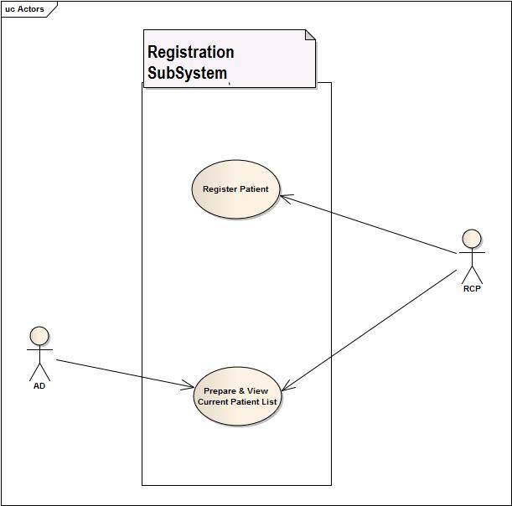

Fig: use-case diagram of registration system

**4.4.1.1Resgister Patient**

|  |  |
| --- | --- |
| USE CASE NAME | DEFINE ROUTE AND PRICE |
| USE CASE ID | 1.1 |
| Priority | High |
| Primary Business Actor | Patient (PT) |
| External Receiver Actor | Receptionist (RCP) |
| Description | Receptionist takes the information of the patient and registers him in the system |
| Trigger | By Patient |

**Table:** *Use-Case Narrative:* Register Patient

Typical Course of Events:

|  |  |
| --- | --- |
| Actor Action | System Response |
| Step 1. PT fill up the forms in hospital | Step 3. System creates an account |
| Step 2. RCP fills up the online form | Step 4. Sends user id and pw to PT |

**Documentation of the use-case 1.1**

**Course of the events**

**Conclusion:**

Concludes when a patient is registered to the hospital information system.

**Post-condition:**

A doctor is assigned to the patient.

**Implementation Issues:**

Graphical User interface will be provided in the system software to be registered.

**4.4.1.2 Prepare and View Patient list:**

|  |  |
| --- | --- |
| USE CASE NAME | DEFINE ROUTE AND PRICE |
| USE CASE ID | 1.2 |
| Priority | Medium |
| Primary Business Actor | AD,RCP |
| External Receiver Actor |  |
| Description | System prepares a list of patients currently registered in the system and  AD and RCP views it. |
| Trigger | AD |

**Table:** *Use-Case Narrative:* Prepare Patient list

**Typical Course of Events:**

|  |  |
| --- | --- |
| Actor Action | System Response |
| Step 1. AD asks the system to prepare a list of current PT | Step 2. System produces the list of PT who are currently admitted to the hospital |
| Step 3. AD, RCP views it. |  |

**Documentation of the use-case 1.2**

**Course of the events**

**Conclusion:**

Concludes when information about patients is currently stored and ready to be searched.

**Post-condition:**

The administrator is notified about the current patients.

**Implementation Issues:**

List of patient information is stored in database and prepared for filter searching.

### 4.4.2 Patient Management System

**Use-case Glossary:**

|  |  |  |
| --- | --- | --- |
| Use-case ID>Name | Description | Participant Actors and roles |
| 2.1>Appointment Assign | PT goes to RCP and requests for an appointment, RCP checks the duty schedule of the DOC and makes an appointment | DOC,RCP,PT |
| 2.2>Prepare Prescription | DOC will prepare electronic prescription | DOC |
| 2.3>Update Patient Database | DEM will update the patient database by updating prescription and diagnostic information | DEM |
| 2.4>Cabin/Bed Assign | PT requests for cabin/bed to RCP,RCP contacts with the AD and assigns a bed/cabin | PT,RCP,AD |
| 2.5>Discharge | DOC, CLK permits the PT to be discharged | PT,DOC,CLK |

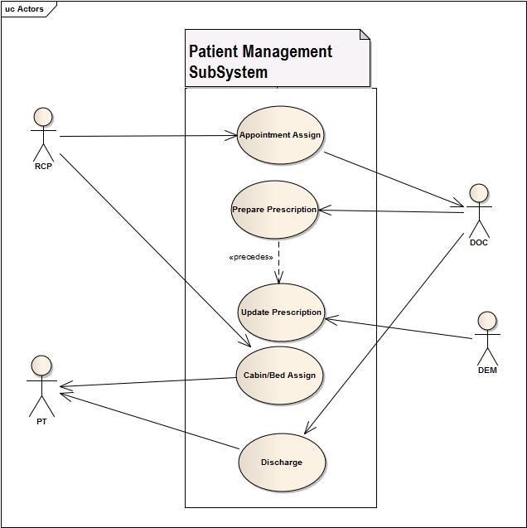

Fig: use-case diagram of patient management system

**4.4.2.1 Appointment Assign:**

|  |  |
| --- | --- |
| USE CASE NAME | DEFINE ROUTE AND PRICE |
| USE CASE ID | 2.1 |
| Priority | Medium |
| Primary Business Actor | RCP |
| External Receiver Actor | Patient |
| Description | RCP assigns PT appointments |
| Trigger | RCP |

**Table:** *Use-Case Narrative:* Appointment Assign

**Typical Course of Events:**

|  |  |
| --- | --- |
| Actor Action | System Response |
| Step 1. PT wants to visit a DOC | Step 3. System tells whether he is available or not |
| Step 2. RCP searches for availability | Step 5. System Updates DOC appointment list |
| Step 4. RCP appoints an appointment |  |

**Documentation of the use-case 2.1**

**Course of the events**

**Conclusion:**

Concludes when a registered patient is assigned or referred to a doctor.

**Post-condition:**

Doctor gives the patient treatment.

**Implementation Issues:**

A doctor of certain department is assigned to his profile or doctor’s id will be given to his/her profile by the receptionist.

**4.4.2.2 Prepare Prescription:**

|  |  |
| --- | --- |
| USE CASE NAME | DEFINE ROUTE AND PRICE |
| USE CASE ID | 2.2 |
| Priority | High |
| Primary Business Actor | DOC |
| External Receiver Actor | Patient |
| Description | DOC prepares and gives prescription |
| Trigger | DOC |

**Table:** *Use-Case Narrative:* Prepare Prescription

Typical Course of Events:

|  |  |
| --- | --- |
| Actor Action | System Response |
| Step 1. PT visit DOC |  |
| Step 2. DOC prescribes PT |  |

**Documentation of the use-case 2.2**

**Course of the events**

**Conclusion:**

When doctor gives a prescription and uploaded to patient database by generating electrically.

**Post-condition:**

Provides the prescription to the patient representative.

**Implementation Issues:**

A analog hand written prescription will be digitalized and upload to patient database.

**4.4.2.3 Update Patient Database:**

|  |  |
| --- | --- |
| USE CASE NAME | DEFINE ROUTE AND PRICE |
| USE CASE ID | 2.3 |
| Priority | High |
| Primary Business Actor | DEM |
| External Receiver Actor |  |
| Description | DEM updates patients DB with new prescription |
| Trigger | DEM |

**Table:** *Use-Case Narrative:* Update Patient Database

Typical Course of Events:

|  |  |
| --- | --- |
| Actor Action | System Response |
| Step 1. PT take the prescription to DEM | Step 3. System Updates PT account |
| Step 2. DEM insert them to PT account |  |

**Documentation of the use-case 2.3**

**Course of the events**

**Conclusion:**

When all the current information are properly updated to database.

**Post-condition:**

Then database will be there for further changes.

**Implementation Issues:**

The data entry manager will update the system database with update button and patients profile information will get current status.

**4.4.2.4 Cabin/ Bed Assign**

|  |  |
| --- | --- |
| USE CASE NAME | DEFINE ROUTE AND PRICE |
| USE CASE ID | 2.4 |
| Priority | High |
| Primary Business Actor | PT |
| External Receiver Actor | RCP, AD |
| Description | RCP assigns bed/cabin to patient if AD approves it |
| Trigger | RCP |

**Table:** *Use-Case Narrative:* Cabin/ Bed Assign

Typical Course of Events:

|  |  |
| --- | --- |
| Actor Action | System Response |
| Step 1. PT asks RCP for a bed | Step 3. System shows available bed |
| Step 2. RCP searches for available bed | Step 5. System updates bed list and PT account |
| Step 4. RCP assigns a bed to PT |  |

**Documentation of the use-case 2.4**

**Course of the events**

**Conclusion:**

When receptionist assigns a bed or cabin if the patient is required to be admitted or want to be admitted.

**Post-condition:**

Patients will be issued a bed or cabin (if available) and costs starts adding up.

**Implementation Issues:**

Bed or cabin no will be assigned to his/her profile.

4.4.2.5 Discharge:

|  |  |
| --- | --- |
| USE CASE NAME | DEFINE ROUTE AND PRICE |
| USE CASE ID | 2.5 |
| Priority | High |
| Primary Business Actor | DOC, CLK |
| External Receiver Actor | PT |
| Description | DOC and CLK provides certificate that he is allowed to leave the hospital and PT is discharged |
| Trigger | DOC |

**Table:** *Use-Case Narrative:* Discharge

Typical Course of Events:

|  |  |
| --- | --- |
| Actor Action | System Response |
| Step 1. DOC approves discharge of a patient | Step 3. System Discharges the PT |
| Step 2. CLK checks for dues in PT account |  |

**Documentation of the use-case 2.5**

**Course of the events**

**Conclusion:**

When patients profile is closed.

**Post-condition:**

The system will preserve patient profile as past patient.

**Implementation Issues:**

Administrator closes the patient profile and doesn’t update it until the patient recontact with hospital.

### 4.4.3 Employee Management System:

**Use-case glossary:**

|  |  |  |
| --- | --- | --- |
| Use-case ID>Name | Description | Participant Actors and roles |
| 3.1> Employee Profile Creation | AD creates new employee profile for each employee in the hospital | AD,EMP |
| 3.2>Receive and Distribute Duty Schedule | HRO gets the duty schedule from 6.2 and gives it to the EMP | HRO |
| 3.3>View Employee List | AD can view the employee list | AD |
| 3.4>Update Employee Profile | AD can update employee profile, AD can also fire an employee, AD changes the pay scale salary | AD,EMP |
| 3.5> Leave Management | EMP applies for leave , AD grants/denies the request and send it back to Scheduling Subsystem | AD,EMP |

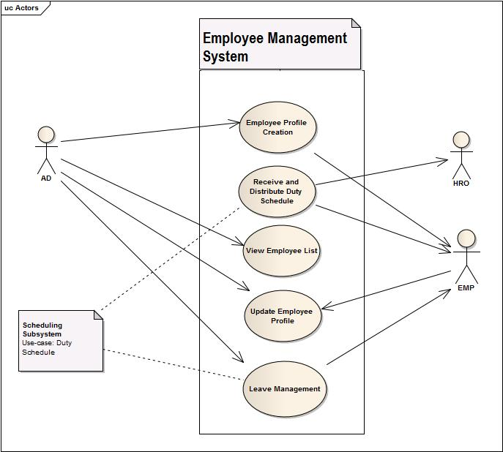

Fig: use-case diagram of Employee Management System

**4.4.3.1: Employee Profile Creation:**

|  |  |
| --- | --- |
| USE CASE NAME | DEFINE ROUTE AND PRICE |
| USE CASE ID | 3.1 |
| Priority | High |
| Primary Business Actor | EMP |
| External Receiver Actor | AD |
| Description | AD registers an EMP in the system |
| Trigger | AD |

**Table:** *Use-Case Narrative:* Employee Profile Creation

**Typical Course of Events:**

|  |  |
| --- | --- |
| Actor Action | System Response |
| Step 1. Employee Joins the Hospital | Step 4. System Creates EMP profile |
| Step 2. Provides Information to AD |  |
| Step 3. AD insert information in System |  |

**Documentation of the use-case 3.1**

**Course of the events**

**Conclusion:**

Concludes when a employee is adopted and all the informations are gathered in the database.

**Post-condition:**

The employee profile is created and prepared for further use.

**Implementation Issues:**

A System GUI will be provided to entry a employee informations which can be accessed by administrator.

**4.4.3.2 Receive and Distribute Duty Schedule:**

|  |  |
| --- | --- |
| USE CASE NAME | DEFINE ROUTE AND PRICE |
| USE CASE ID | 3.2 |
| Priority | MED |
| Primary Business Actor | HRO |
| External Receiver Actor | EMP |
| Description | HRO receives the duty schedule from the scheduling subsystem  And distributes it among the EMP |
| Trigger | HRO |

**Table:** *Use-Case Narrative:* Receive and Distribute Duty Schedule

Typical Course of Events:

|  |  |
| --- | --- |
| Actor Action | System Response |
| Step 1. HRO receives duty schedule from Scheduling subsystem |  |
| Step 2. HRO distributes them among employees |  |

**Documentation of the use-case 3.2**

**Course of the events**

**Conclusion:**

Concludes when schedules are distributed to the employees.

**Post-condition:**

The employees are notified by some ways(sms or electrical screen).

**Implementation Issues:**

A routine type schedule will be created daily basis for doctors and employees by system and will be displayed on digital screen or notified by sms.

**4.4.3.3 View Employee List:**

|  |  |
| --- | --- |
| USE CASE NAME | DEFINE ROUTE AND PRICE |
| USE CASE ID | 3.3 |
| Priority | Low |
| Primary Business Actor | AD |
| External Receiver Actor |  |
| Description | AD can view the current EMP list |
| Trigger | AD |

Table: *Use-Case Narrative:* View Employee List

**Typical Course of Events:**

|  |  |
| --- | --- |
| Actor Action | System Response |
| Step 1. AD wants to view the admitted PT list | Step 2 . System shows it |

**Documentation of the use-case 3.3**

**Course of the events**

**Conclusion:**

When employee lists is shown on software GUI(with filter searching).

**Post-condition:**

Administrator can do permitted operations on employee (salary increment ,fire etc).

**Implementation Issues:**

All employee lists will be prepared and showed on the GUI based on(with or without filtering) searching and will be provided options for permitted changes.

**4.4.3.4 Update Employee Profile:**

|  |  |
| --- | --- |
| USE CASE NAME | DEFINE ROUTE AND PRICE |
| USE CASE ID | 3.4 |
| Priority | MED |
| Primary Business Actor | EMP |
| External Receiver Actor | AD |
| Description | AD can update information of EMP |
| Trigger | EMP |

**Table:** *Use-Case Narrative:* Update Employee Profile

**Typical Course of Events:**

|  |  |
| --- | --- |
| Actor Action | System Response |
| Step 1. AD inserts updated information | Step 2. System Updates it |

**Documentation of the use-case 3.4**

**Course of the events**

**Conclusion:**

Concludes when changes made by administrator is updated.

**Post-condition:**

The new information about the employees will now exist in the system and concerned employee will be notified.

**Implementation Issues:**

Administrator views and changes employee information and updates the employee information and employee will be notified by sms.

**4.4.3.5 Leave Management:**

|  |  |
| --- | --- |
| USE CASE NAME | DEFINE ROUTE AND PRICE |
| USE CASE ID | 3.5 |
| Priority | High |
| Primary Business Actor | EMP |
| External Receiver Actor | AD |
| Description | AD has to approve leave for an EMP and Updates DB as so |
| Trigger | EMP |

**Table:** *Use-Case Narrative:* Leave Management

Typical Course of Events:

|  |  |
| --- | --- |
| Actor Action | System Response |
| Step 1. EMP requests for Leave | Step 3. If accepted then Profile is updated |
| Step 2. AD chooses to accept or deny | Step 4. Updated info is sent to Scheduling subsystem |

**Documentation of the use-case 3.5**

**Course of the events**

**Conclusion:**

When employee absence is adapted in the system.

**Post-condition:**

System scheduling and other things will be updated.

**Implementation Issues:**

If administrator accepts the leave prayer then he/she will be notified by sms and system scheduling will be done adapted.

### 4.4.4. Billing System:

Use-case Glossary:

|  |  |  |
| --- | --- | --- |
| Use-case ID>Name | Description | Participant Actors and roles |
| 4.1>Collect Bill Information | CLK collects all billing information from different sub system | CLK |
| 4.2>Receive bill and Produce receipt | PT gives total bill to CLK and RCP produce a receipt. | PT,CLK |

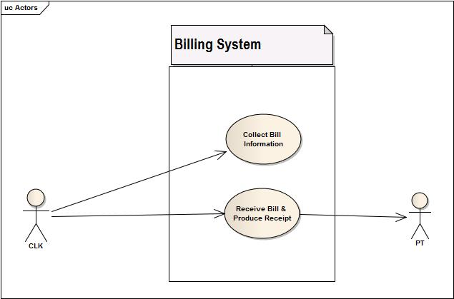

**Fig: use-case diagram of Billing System**

**4.4.4.1Collect Bills from other subsystems:**

|  |  |
| --- | --- |
| USE CASE NAME | DEFINE ROUTE AND PRICE |
| USE CASE ID | 4.1 |
| Priority | High |
| Primary Business Actor | CLK |
| External Receiver Actor |  |
| Description | CLK collects all bills from Patient profile |
| Trigger | CLK |

**Table:** *Use-Case Narrative:* Collect Bills from other subsystems

Typical Course of Events:

|  |  |
| --- | --- |
| Actor Action | System Response |
| Step 1. CLK checks for all bills in PT account | Step 2.System shows the pt account |
|  | Step 2. System collects all bills and prepare them |

**Documentation of the use-case 4.1**

**Course of the events**

**Conclusion:**

Concludes when all costs and costs sent from other systems are summed up.

**Post-condition:**

System will prepare full bill list.

**Implementation Issues:**

All services charges, doctor fees, cabin or bed cost(depends on how long patients stayed),diagnostic costs are added.

**4.4.4.2 Receive Bill and Produce Receipt:**

|  |  |
| --- | --- |
| USE CASE NAME | DEFINE ROUTE AND PRICE |
| USE CASE ID | 4.2 |
| Priority | High |
| Primary Business Actor | PT |
| External Receiver Actor | CLK |
| Description | PT pays bill to CLK |
| Trigger | PT |

**Table:** *Use-Case Narrative:* Receive Bill

**Typical Course of Events:**

|  |  |
| --- | --- |
| Actor Action | System Response |
| Step1. PT pay bill to CLK | Step 2. System updates PT account |

**Documentation of the use-case 4.2**

**Course of the events**

**Conclusion:**

When patient profile will be updated as all costs paid.

**Post-condition:**

System will provide the patient discharge grant through administrator.

**Implementation Issues:**

Costs paid by the patients will be sent to patient profile to be cleared up and remove dues status.

### 4.4.5 Scheduling System

**Use-case Glossary:**

|  |  |  |
| --- | --- | --- |
| Use-case ID>Name | Description | Participant Actors and roles |
| 5.1>Active Employee List | AD gets the active employee list | AD |
| 5.2>Duty Schedule | AD specifies duty schedules of all employees | AD |

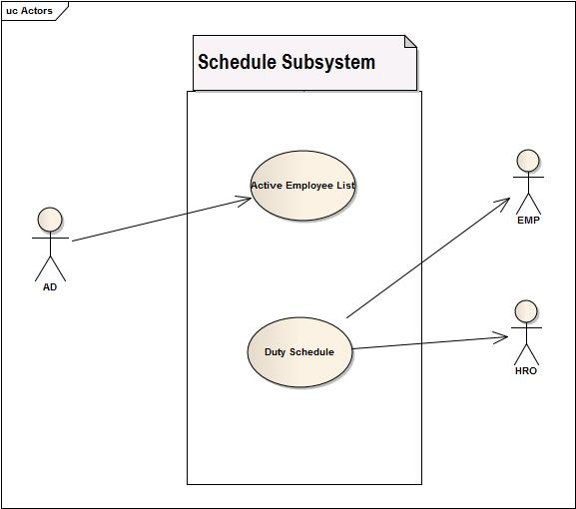

**Fig: use-case diagram of Scheduling System**

**4.4.5.1 Receive Active Employee**

|  |  |
| --- | --- |
| USE CASE NAME | DEFINE ROUTE AND PRICE |
| USE CASE ID | 5.1 |
| Priority | Med |
| Primary Business Actor | AD |
| External Receiver Actor |  |
| Description | System receive active employee list |
| Trigger | AD |

Table: *Use-Case Narrative:* Receive Active Employee

Typical Course of Events:

|  |  |
| --- | --- |
| Actor Action | System Response |
|  | Step 1.Receive the list of active employees |

**Documentation of the use-case 5.1**

**Course of the events**

**Conclusion:**

Concludes by preparing a list of employee who are currently active.

**Post-condition:**

All active employees will be ready to be scheduled.

**Implementation Issues:**

A list will be prepared by system depending on on-leave status of the employee and other criteria.

**4.4.5.2 Duty Schedule**

|  |  |
| --- | --- |
| USE CASE NAME | DEFINE ROUTE AND PRICE |
| USE CASE ID | 5.2 |
| Priority | High |
| Primary Business Actor | AD |
| External Receiver Actor |  |
| Description | System produces duty schedule |
| Trigger | AD |

**Table:** *Use-Case Narrative:* Duty Schedule

Typical Course of Events:

|  |  |
| --- | --- |
| Actor Action | System Response |
|  | Step 1. Produce a work schedule for all emp |
|  | Step 2. Send it to HRO |

**Documentation of the use-case 5.2**

**Course of the events**

**Conclusion:**

Concludes when all duty schedule are prepared checking employees information.

**Post-condition:**

Concerned employee will be notified for their duties.

**Implementation Issues:**

A digital screen will show schedule list. Also employee will be notified by sms according to their tasks.

## 4.5 Fishbone Diagram

Fishbone Diagram of Registration Subsystem

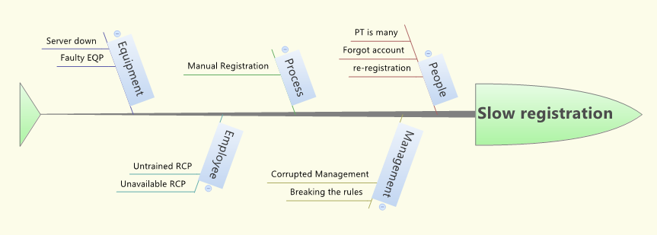

Fishbone Diagram of Patient Management System

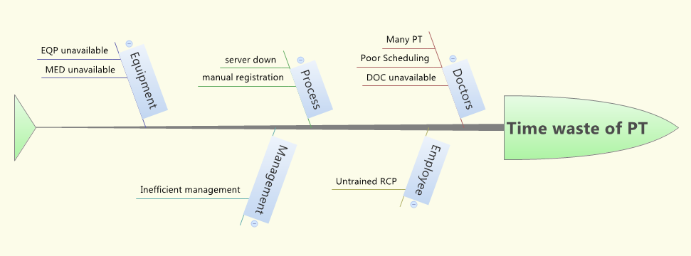

Fishbone Diagram of Employee Management Subsystem

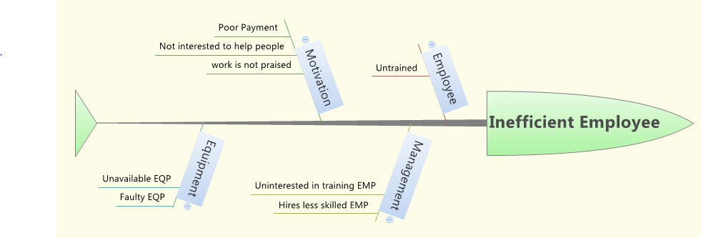

Fishbone Diagram of Billing Subsystem

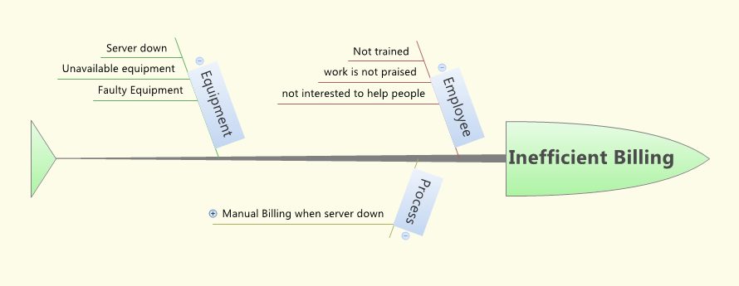

Fishbone Diagram of Scheduling Subsystem

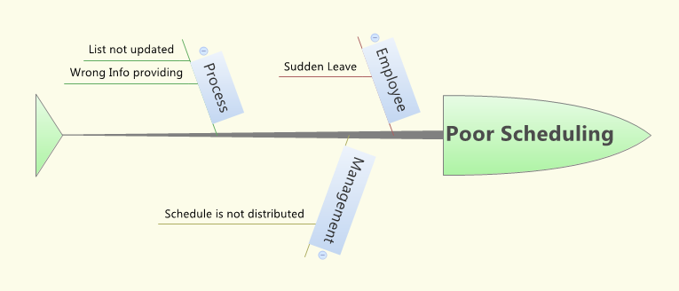

4.6 Data Flow Diagram**:**

### 4.6.1 Data Flow Diagram of Registration Subsystem

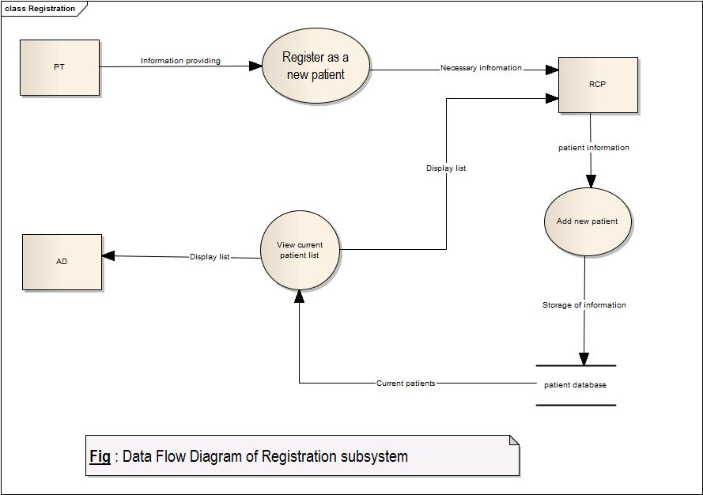

### 4.6.2 Data Flow Diagram of Patient Management Subsystem

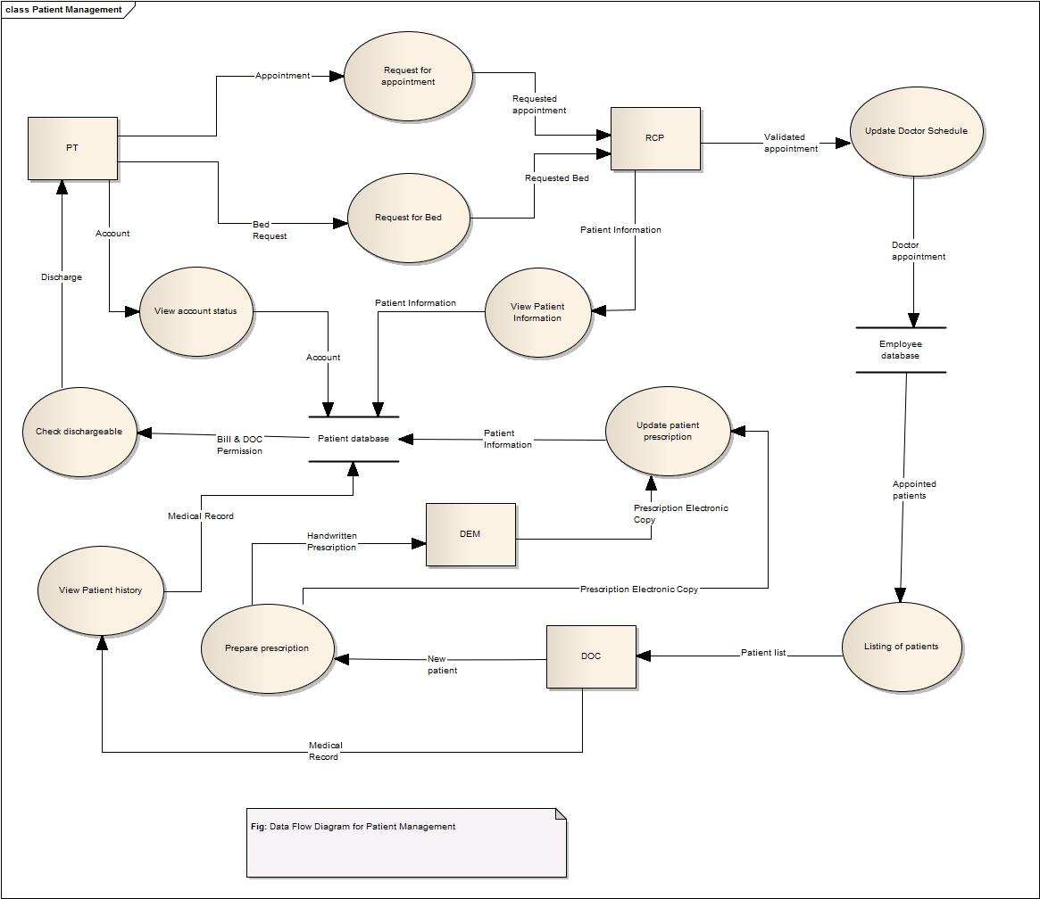

### 4.6.3 Data Flow Diagram of Employee Management Subsystem

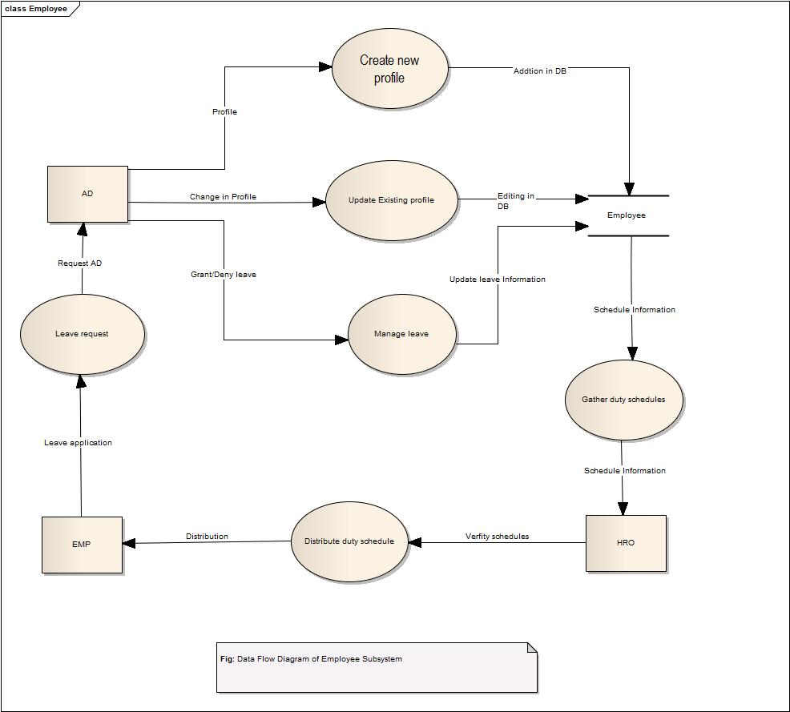

### 4.5.4 Data Flow Diagram of Billing Subsystem

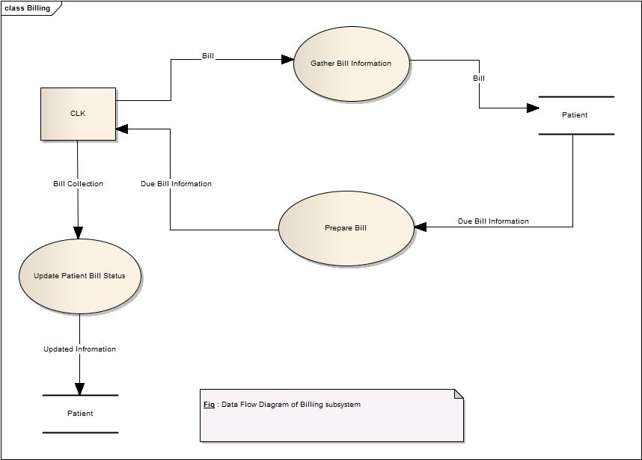

### Data Flow Diagram of Scheduling Subsystem

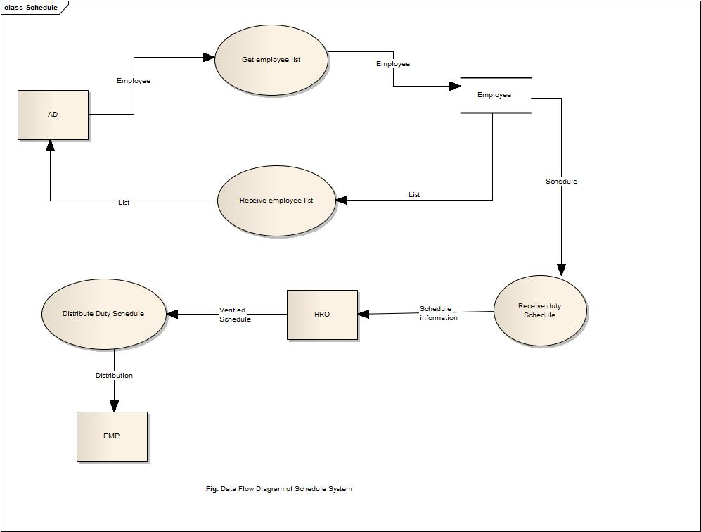

4.6 System Design**:**

### 4.6.1 Class Diagram:

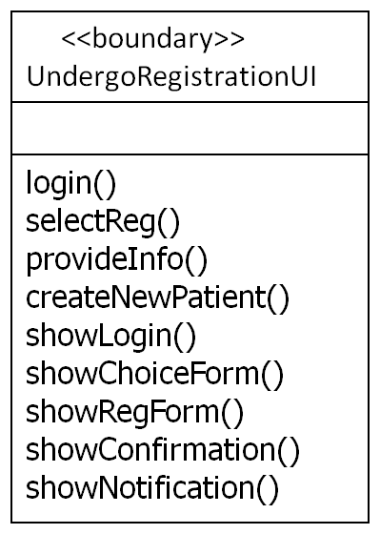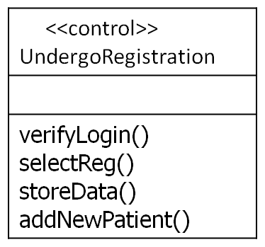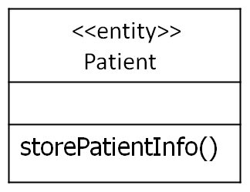

0.....*

1

**Fig : class Diagram for Registering Patient**

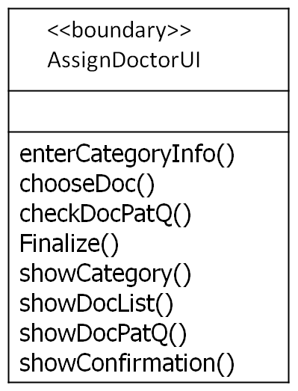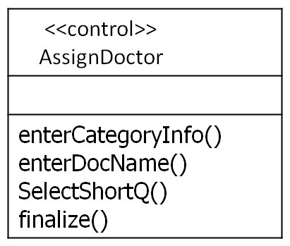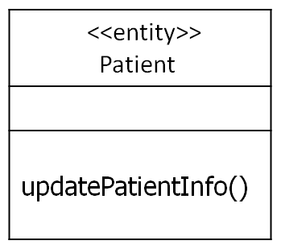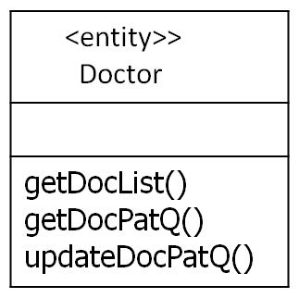

1.....*

1

1.....*

1

**Fig: Class Diagram for Assign Doctor**

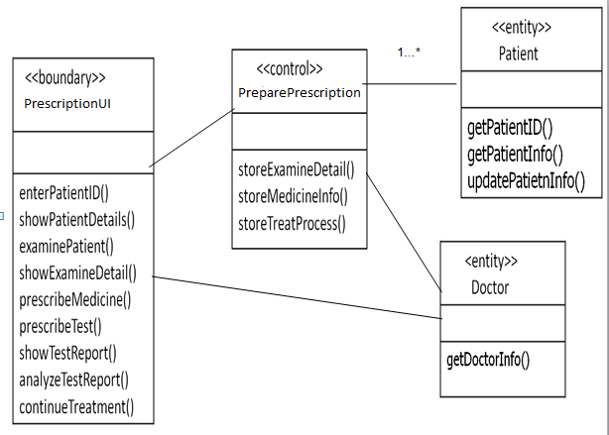

**Fig: Class Diagram for Prepare Prescription**

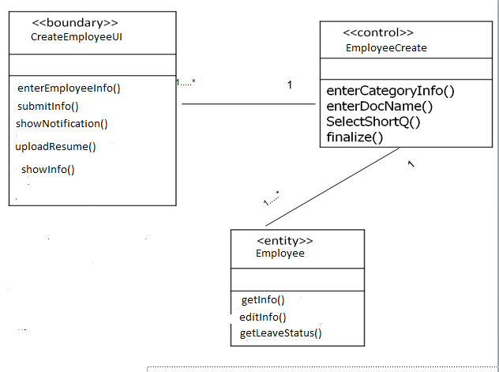

**Fig: class Diagram for Employee Creation**

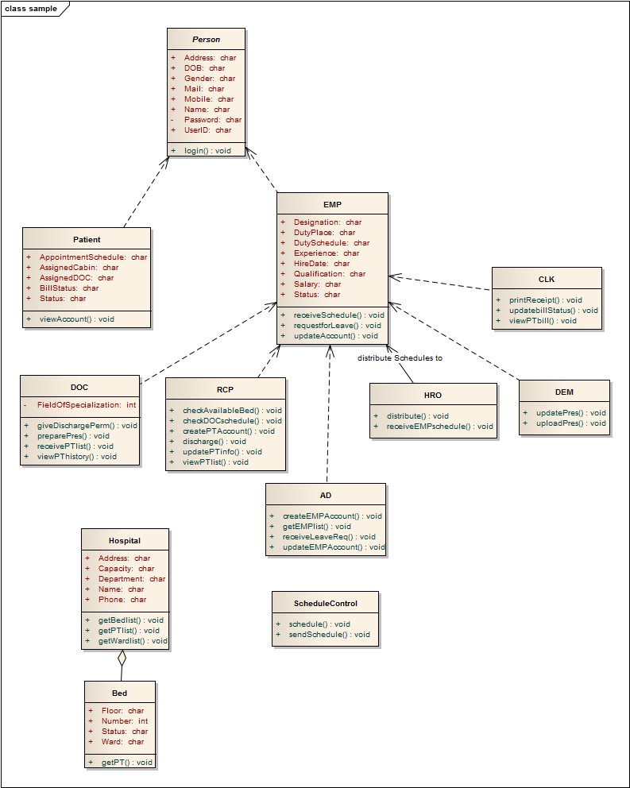

Fig: Class Hierarchy

### 4.6.2 Collaboration Diagram:

**Use case wise collaboration diagram:**

**Use case 1.1: Register Patient**

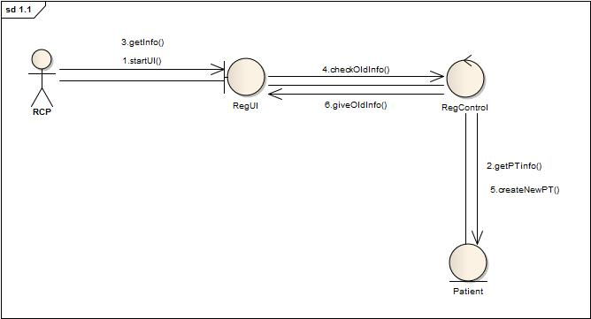

**Use case 1.2: Prepare and View Patient List**

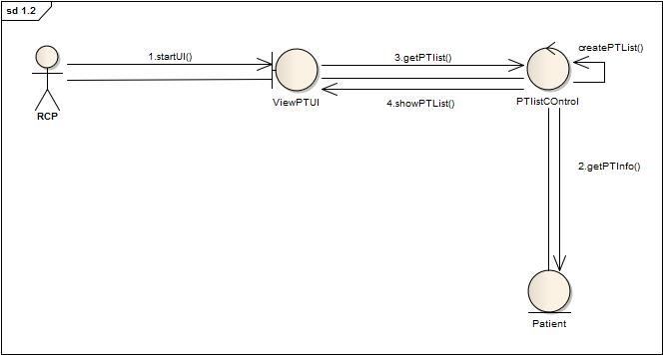

**Use case 2.1: Appointment Assign**

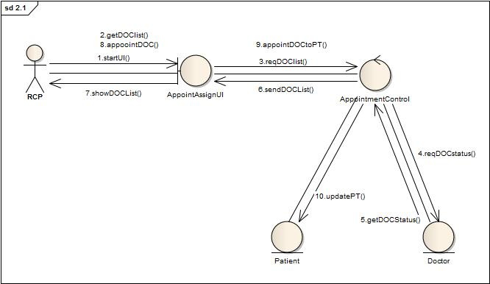

**Use case 2.2: Write Prescription**

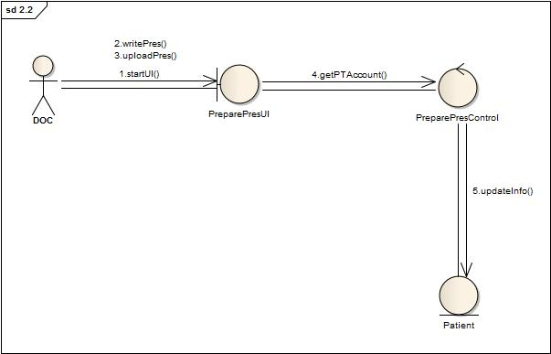

**Use case 2.3: Upload Prescription**

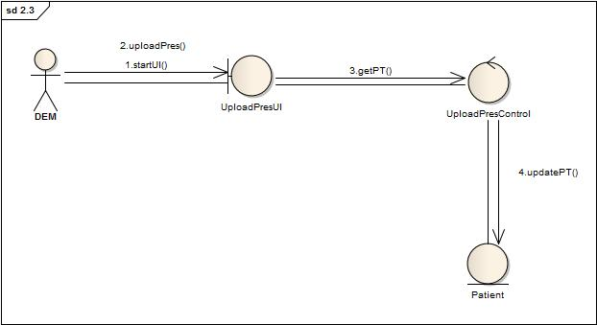

**Use case 2.4: Cabin/Bed Assign**

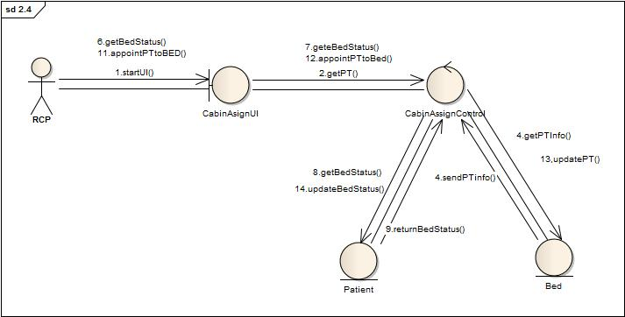

**Use case 2.5: Discharge Patient**

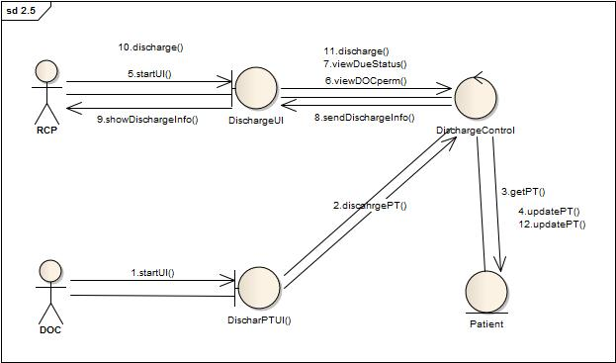

**Use case 3.1: Create New Account**

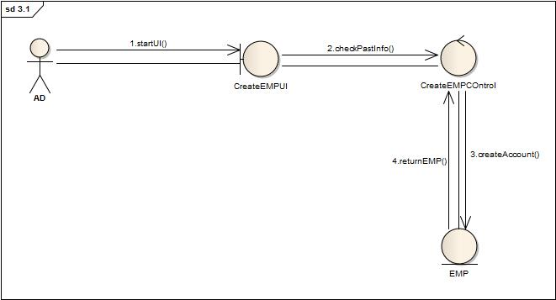

**Use case 3.2: Receive and Distribute Schedule**

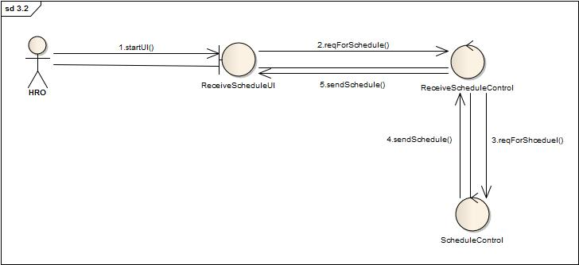

**Use case 3.3: Prepare and View Employee List**

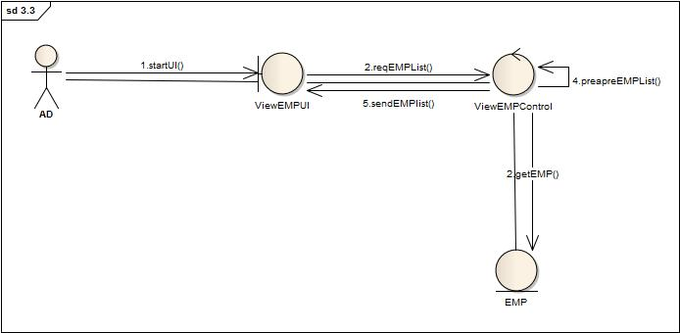

**Use case 3.4: Update Employee Profile**

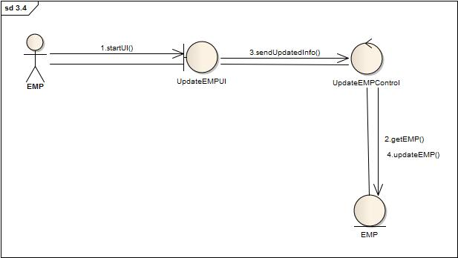

**Use case 3.5: Leave Management**

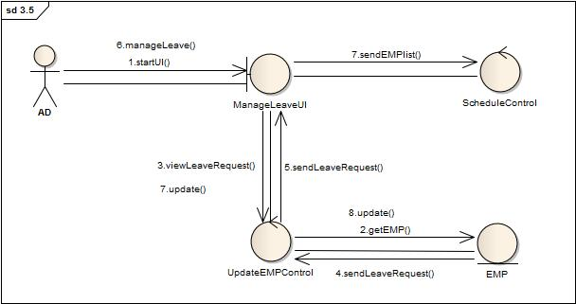

**Use case 4.1: Get Bill Information**

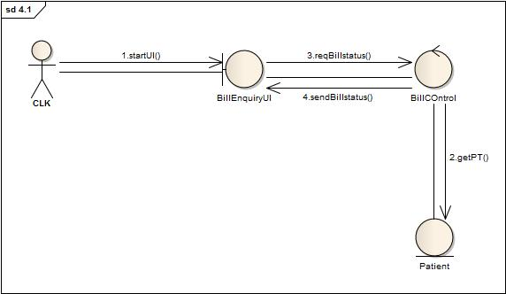

**Use case 4.2: Receive Bill**

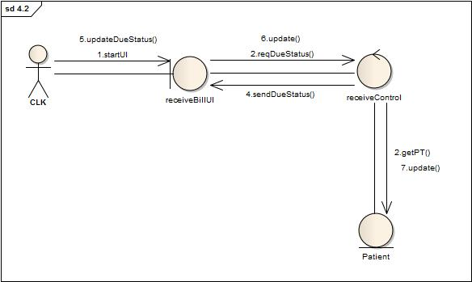

**Use case 5.1: Get Active Employee List**

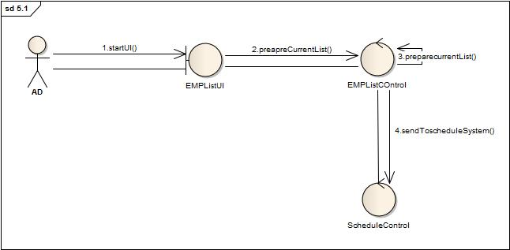

**Use case 5.2:Schedule**

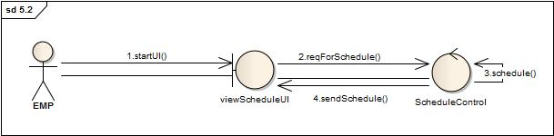

## 4.6 Process Design:

### 4.6.1 Sequence Diagram:

**Use case wise sequence diagram:**

**Use case 1.1: Register Patient**

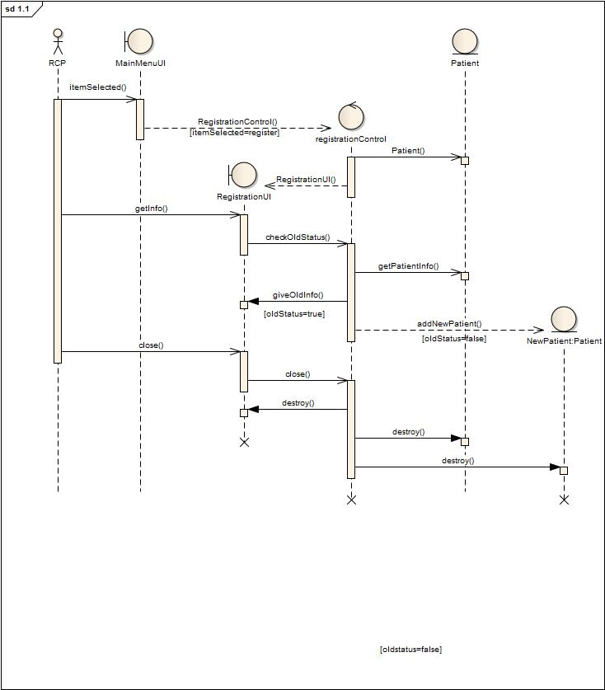

**Use case 1.2: Prepare and View Patient List**

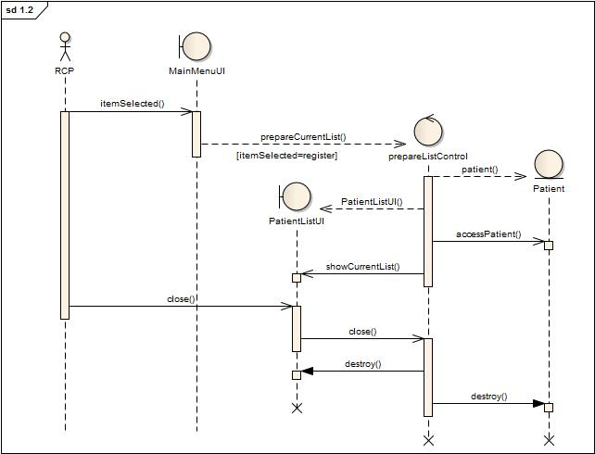

**Use case 2.1:Appointment Assign**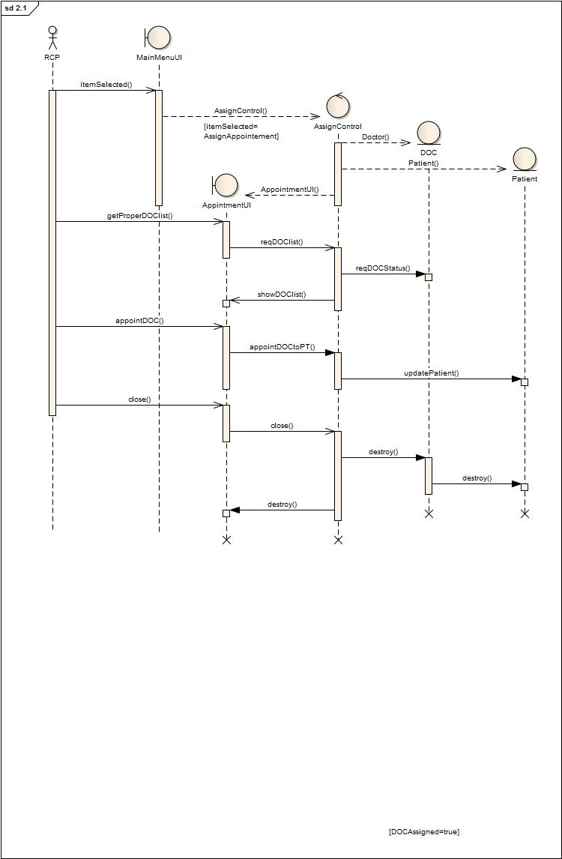

**Use case 2.2: Prepare Prescription**

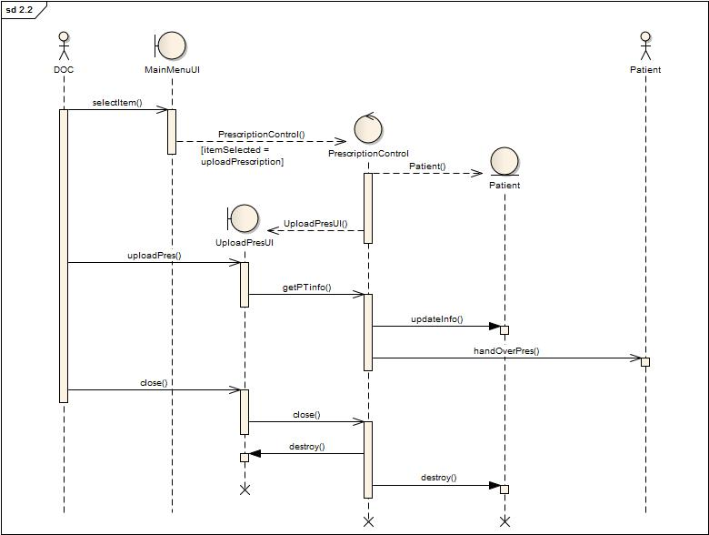

**Use case 2.3: Upload Prescription**

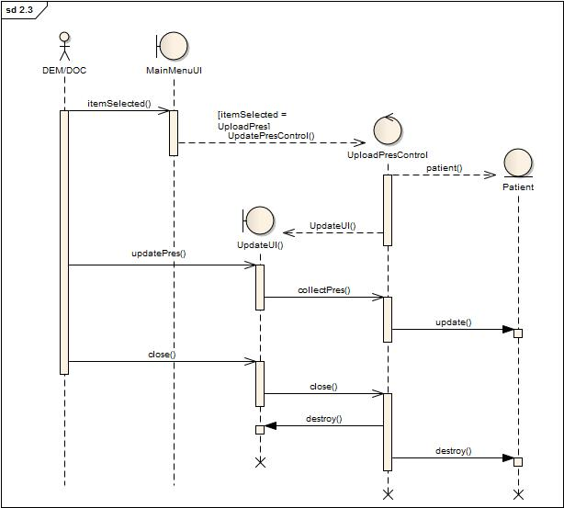

**Use case 2.4:Cabin/Bed Assign**

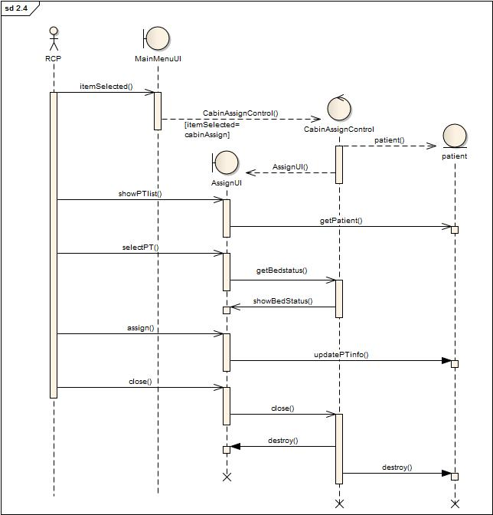

**Use case 2.5:Discahrge**

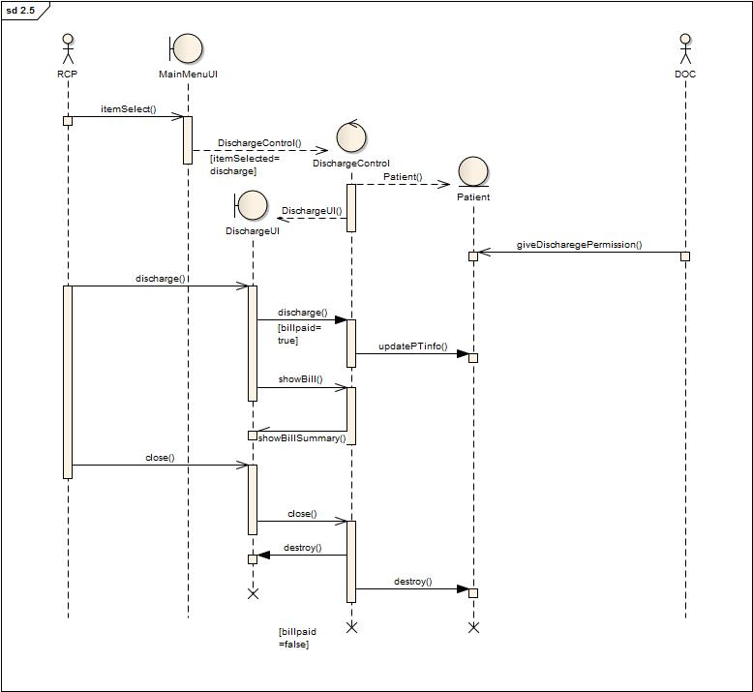

**Use case 3.1: Create Employee Account**

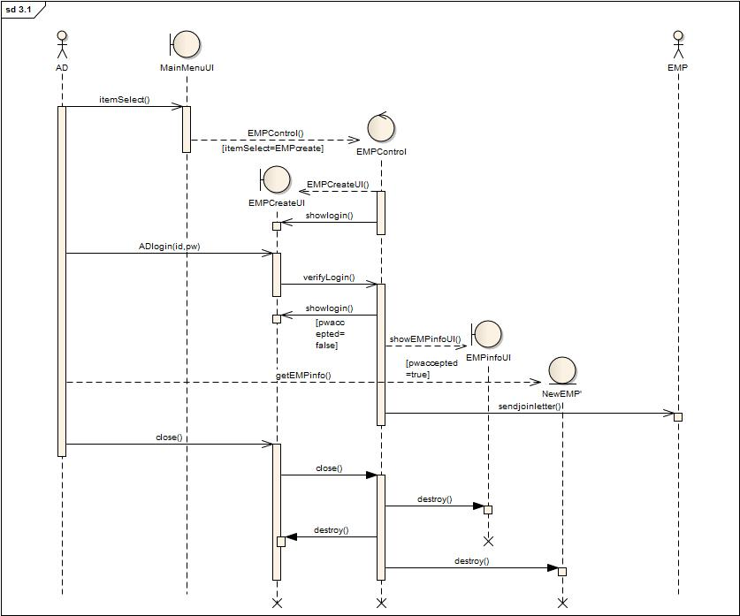

**Use case 3.2: Receive and Distribute Duty Schedule**

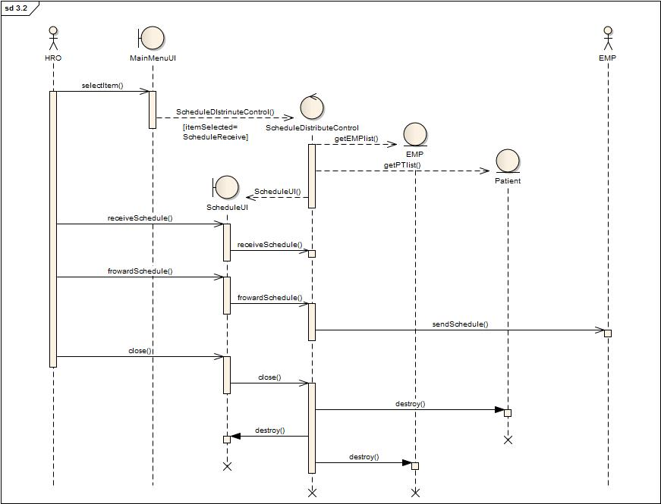

**Use case 3.3: Prepare and View Employee List**



**Use case 3.4: Update Employee Profile**

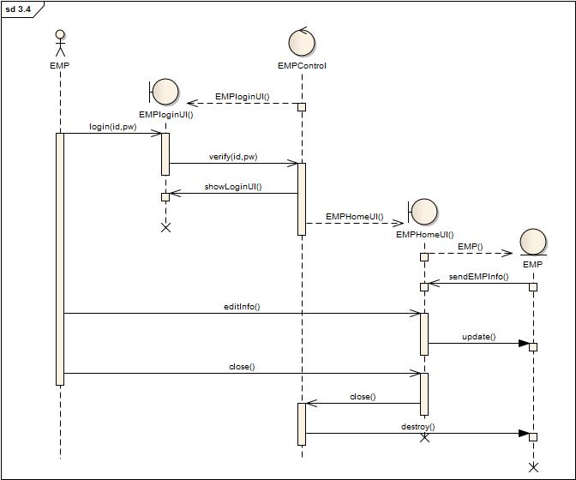

**Use case 3.5: Leave Management**

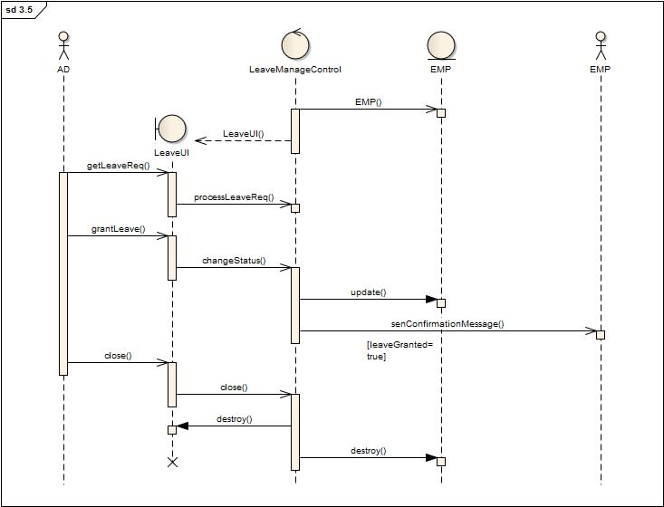

**Use case 4.1: View Bill Infromation**

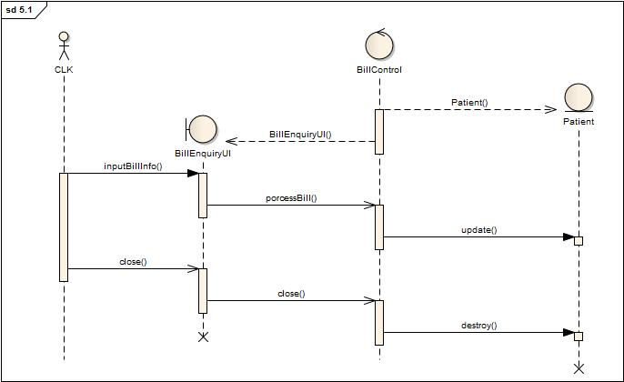

**Use case 4.2:Receive Bill**

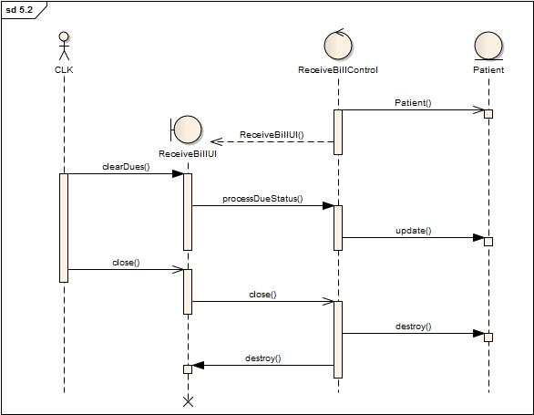

**Use case 5.1: Get Active Employee List**

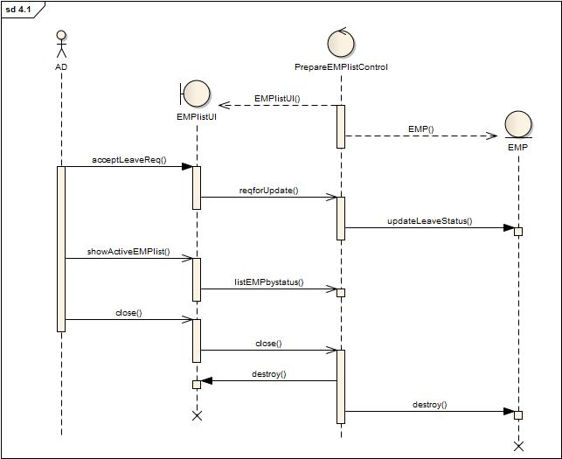

**Use case 5.2:Schedule**

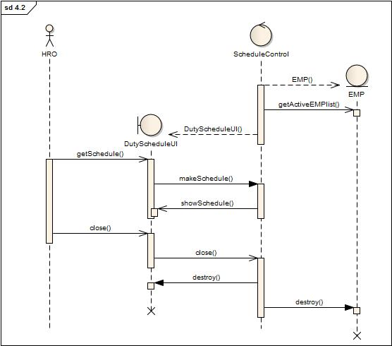

### 4.6.2 Statechart Diagram:

**Statechart Diagram for Patient:**

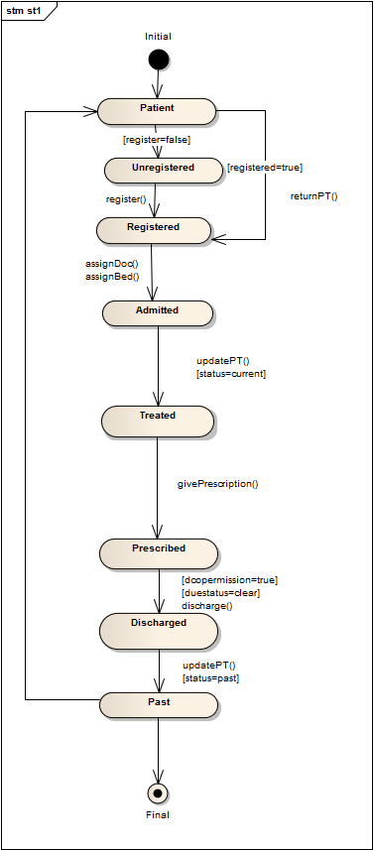

**StateChart Diagram for Employee:**

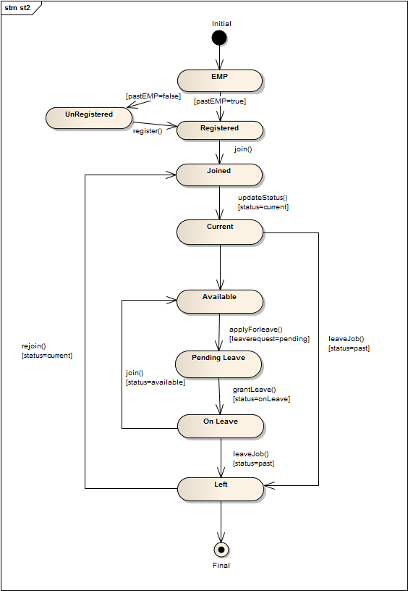

### 4.6.3 Activity Diagram:

**Use case wise activity diagram:**

**Use case 1.1:Register Patient**

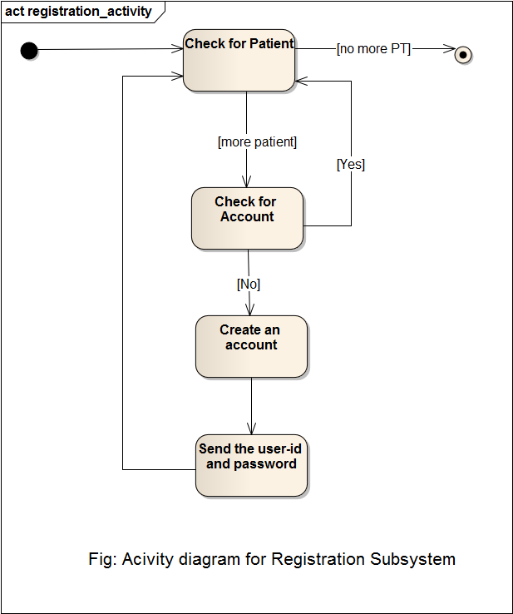

**Use case 1.2: Prepare and View Patient List**

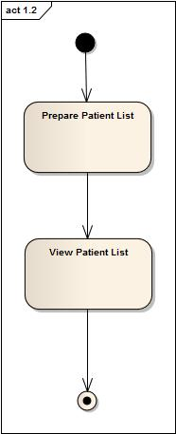

**Use case 2.1: Appointment Assign**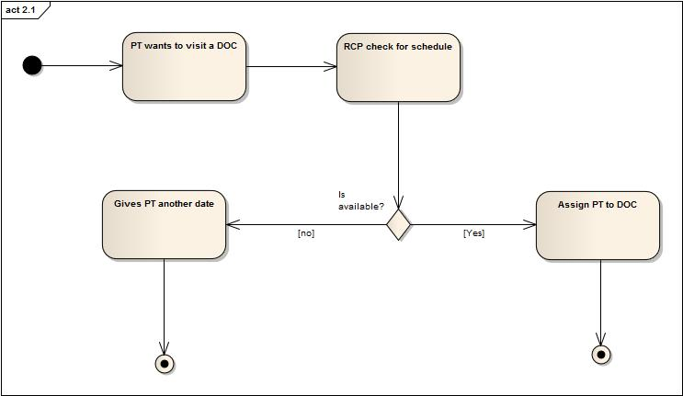

**Use case 2.2:Prepare Prescription**

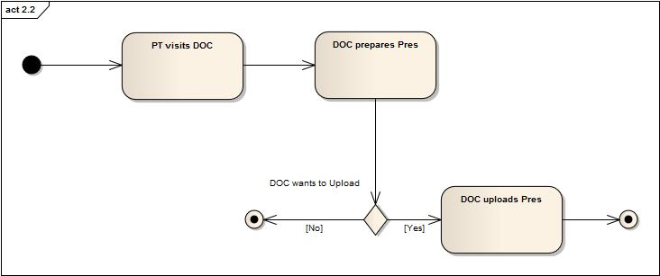

**Use case 2.3:Upload Prescription**

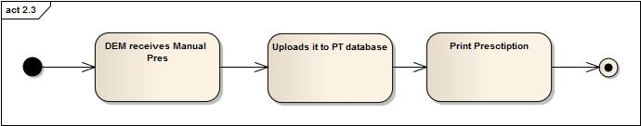

**Use case 2.4:Cabin / Bed Assign**

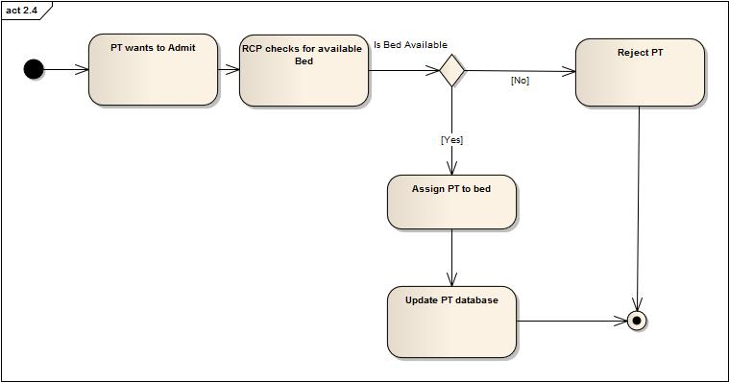

**Use case 2.5:Discharge**

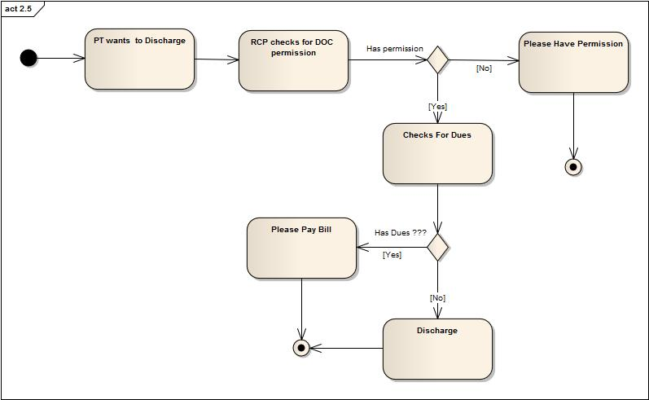

**Use case 3.1:Create New Employee**

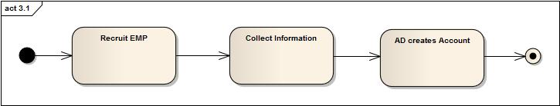

**Use case 3.2: Receive and Distribute Duty Schedule**

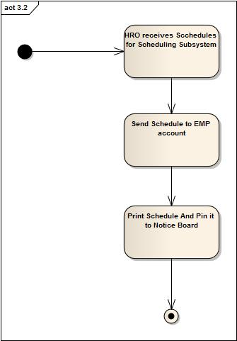

**Use case 3.3: Prepare and View Employee List**

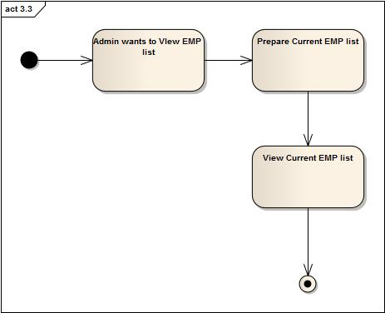

**Use case 3.4: Update Employee Account**

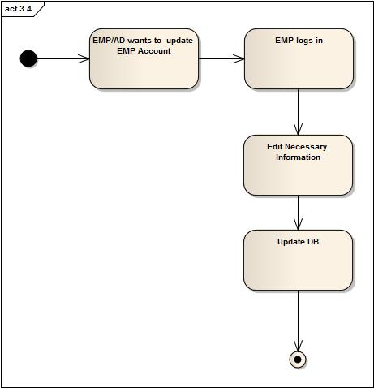

**Use case 3.5: Leave Management**

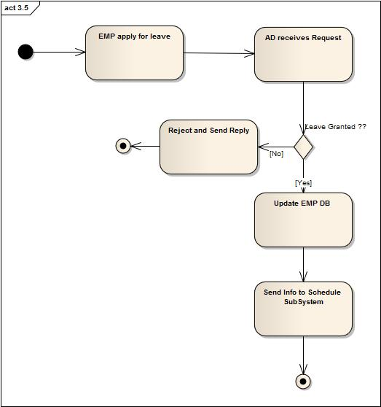

**Use case 4.1: Get Bill Information**

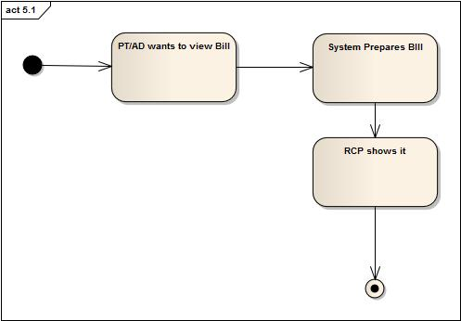

**Use case 4.2: Receive Bill**

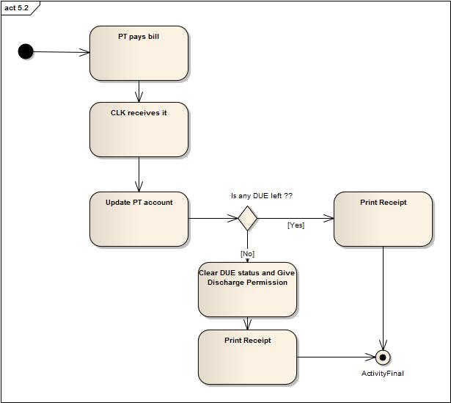

**Use case 5.1: Get Active Employee List**

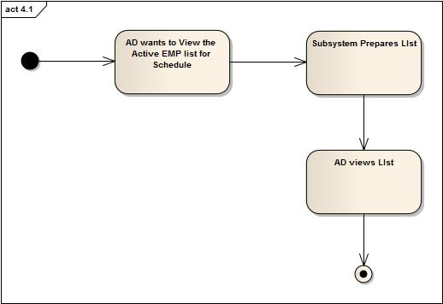

**Use case 5.2: Schedule**

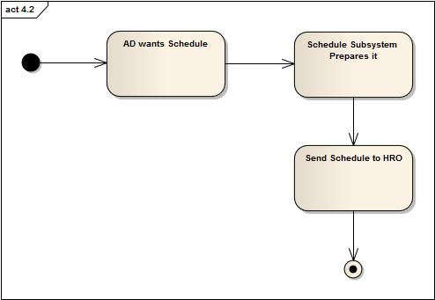

# 5 Database DESIGN

## 5.1 Introduction:

The system we propose in this report integrates the idea to automated, instead of manual information management and scheduling of **DELTA HOSPITAL LIMITED**. It enables to maintain doctor and employee’s schedule, Patient’s medical history such as prescription and billing system etc, which all required human efforts previously. As a result, this new system can reduce possible human errors and provide accurate information of hospital at any point.

Nowadays, more and more hospitals tend to use some available software to maintain information over a long term. We design the Hospital Management System to approach this goal with features that help improve data consistency, managing schedules at a time. With these goals in mind, we decide to incorporate design philosophy as well as user friendly interface into the system, meanwhile to have powerful functions that manifest all the user requirements and needs.

One concern is how to reflect patient information as quick as possible, since this information is need by a huge number of employees daily. In order to offer the best service to the patients in maintaining doctor, nurse and clerk schedule, the Scheduling System and Employee management system can efficiently and accurately accomplish it while provides other services to the hospital such as status of doctors.

To receptionist, the system can provide instant information about all necessary things so the receptionist who manage patient database can immediately solve any quires for the patients, since the system provides easy-to-use interface for receptionist to see patient database and also for the clerk to prepare billing information of the patients. By recording daily patient history, the system updates patient condition constantly with the help of database management system running as the back end.

The previous information management and scheduling method is done manually. Administrator who is in charge of scheduling and information management needs to spend a great deal of time each week to arrange them properly. Obviously this method was prone to human errors. If any patient complains against the provided treatment is was almost impossible to find the given prescription by hospital. Therefore they are facing judicial harassments even if they give the patient proper treatment. Furthermore, if doctors of other hospital quires about the treatment given to a specific patient it is almost impossible to retrieve that. Since the proposed system keeps track of every patient and provided treatment, it can easily provides concurrent information of each patient’s condition and given treatment, while at the same time greatly improves efficiency of hospital.

## 5.2 ERD Diagram:

Complete ER Diagram :



Entitys Person :



**ISA Hierarchy Person:**



Patient:



**Employee ,OfficeStaff , Doctor, Nurse and Time Duration:**



**Entity with Attributes :**



**Entity with Attributes :**



**Patient Doctor Entity Relationship:**



**Entity Relationship:**



**Entity Relationship:**



**Entity Relationship:**



## 5.3 Relational Schema:

Person

|  |  |
| --- | --- |
| Attribute | Data Type |
| Name | Varchar2 |
| Address | Varchar2 |
| ID | Varchar2 |
| PW | Varchar2 |
| Email | Varchar2 |
| Status | Varchar2 |
| Mobile | Varchar2 |
| Phone | Varchar2 |
| Age | Number |
| BloodGroup | Varchar2 |
| DocPermission | Varchar2 |

Doctor

|  |  |
| --- | --- |
| Attribute | Data Type |
| DID | Varchar2 |
| Specialization | Varchar2 |

Patient

|  |  |
| --- | --- |
| Attribute | Data Type |
| BedID | Varchar2 |
| Type | Varchar2 |
| Due | Varchar2 |
| DID | Varchar2 |

EMP

|  |  |
| --- | --- |
| Attribute | Data Type |
| EID | Varchar2 |
| Salary | Number |
| Status | Varchar2 |
| Qualification | Varchar2 |

Nurse

|  |  |
| --- | --- |
| Attribute | Data Type |
| Specialization | Varchar2 |
| NID | Varchar2 |

Time Duration

|  |  |
| --- | --- |
| Attribute | Data Type |
| BedID | Varchar2 |
| Type | Varchar2 |
| Due | Varchar2 |
| DID | Varchar2 |

Block

|  |  |
| --- | --- |
| Attribute | Data Type |
| BedID | Varchar2 |
| Type | Varchar2 |
| Due | Varchar2 |
| DID | Varchar2 |

Bed

|  |  |
| --- | --- |
| Attribute | Data Type |
| BedID | Varchar2 |
| Rent | Number |
| WardID | Varchar2 |
| Type | Varchar2 |

Ward

|  |  |
| --- | --- |
| Attribute | Data Type |
| NumOfBeds | Number |
| WardId | Varchar2 |
| Type | Varchar2 |
| Name | Varchar2 |
| BlockID | Varchar2 |

OtherStuff

|  |  |
| --- | --- |
| Attribute | Data Type |
| NumOfBeds | Number |
| WardId | Varchar2 |
| Type | Varchar2 |
| Name | Varchar2 |
| BlockID | Varchar2 |

Singlepres

|  |  |
| --- | --- |
| Attribute | Data Type |
| PresId | Varchar2 |
| BeginDate | Varchar2 |
| Dosage | Varchar2 |
| NumberTaken | Nubmer |
| Comment | Varchar2 |
| Duration | Number |
| MedID | Varchar2 |

Workplace

|  |  |
| --- | --- |
| Attribute | Data Type |
| PlaceID | Varchar2 |
| BlockID | Varchar2 |
| Name | Varchar2 |
| RoomNo | Varchar2 |
| Floor | Varchar2 |

Medicine

|  |  |
| --- | --- |
| Attribute | Data Type |
| PlaceID | Varchar2 |
| BlockID | Varchar2 |
| Name | Varchar2 |
| RoomNo | Varchar2 |
| Floor | Varchar2 |

Bill

|  |  |
| --- | --- |
| Attribute | Data Type |
| PlaceID | Varchar2 |
| BlockID | Varchar2 |
| Name | Varchar2 |
| RoomNo | Varchar2 |
| Floor | Varchar2 |

PTDOChistory

|  |  |
| --- | --- |
| Attribute | Datatype |
| PID | Varchar2 |
| DID | Varchar2 |
| StartDate | Date |
| EndDate | Date |
| Summary | Varchar2 |

PTBed

|  |  |
| --- | --- |
| Attribute | Data Type |
| PID | Varchar2 |
| BedID | Varchar2 |
| StartDate | Date |
| EndDate | Date |

AppointSchedule

|  |  |
| --- | --- |
| Attribute | Data Type |
| PID | Varchar2 |
| BedID | Varchar2 |
| StartDate | Date |
| EndDate | Date |

NurseSchedule

|  |  |
| --- | --- |
| Attribute | Data Type |
| PID | Varchar2 |
| BedID | Varchar2 |
| StartDate | Date |
| EndDate | Date |
| Attribute | Data Type |
| PID | Varchar2 |
| BedID | Varchar2 |
| StartDate | Date |
| EndDate | Date |

DocSchedule

|  |  |
| --- | --- |
| Attribute | Datatype |
| DID | Varchar2 |
| WardID | Varchar2 |
| StartDate | Date |
| EndDate | Date |

PTDOCpres

|  |  |
| --- | --- |
| Attribute | Datatype |
| PID | Varchar2 |
| DID | Varchar2 |
| PresID | Varchar2 |

OtherStaffSchedule

|  |  |
| --- | --- |
| Attribute | Datatype |
| PID | Varchar2 |
| DID | Varchar2 |
| PresID | Varchar2 |

LeaveSchedule

|  |  |
| --- | --- |
| Attribute | Datatype |
| PID | Varchar2 |
| DID | Varchar2 |
| PresID | Varchar2 |

5.4 Triggers:

|  |  |  |  |  |
| --- | --- | --- | --- | --- |
| **Trigger Name** | | Trigger_Appoint_schedule | | |
| **Time of Execution** | | AFTER INSERT on AppointSchedule | | |
|  | | | | |
| **Actions** | | | | **Remarks** |
| **Commands** | **Attributes** | | **Tables** |
| UPDATE | curDOC | | Patient | Assign requested doctor as curDOC for the Patient. |

|  |  |  |  |  |
| --- | --- | --- | --- | --- |
| **Trigger Name** | | Trigger_Bed_Assign | | |
| **Time of Execution** | | AFTER INSERT on PatientBed | | |
|  | | | | |
| **Actions** | | | | **Remarks** |
| **Commands** | **Attributes** | | **Tables** |
| UPDATE | bed | | Patient | Assign bed to the requested patient attribute. |

|  |  |  |  |  |
| --- | --- | --- | --- | --- |
| **Trigger Name** | | Trigger_onLeave | | |
| **Time of Execution** | | AFTER INSERT in onLeave | | |
|  | | | | |
| **Actions** | | | | **Remarks** |
| **Commands** | **Attributes** | | **Tables** |
| UPDATE | Doctor, EstimatedTime | | AppointSchedule | Update Doctor, EstimatedTime when a doctor is on leave |
| UPDATE | Status | | EMP | Update Employee status to inactive. |

|  |  |  |  |  |
| --- | --- | --- | --- | --- |
| **Trigger Name** | | Trigger_discharge | | |
| **Time of Execution** | | Before Patient is discharged | | |
|  | | | | |
| **Actions** | | | | **Remarks** |
| **Commands** | **Attributes** | | **Tables** |
| UPDATE/SELECT | DOCPermission | | Patient | Check for DOCPermission before a patient to be discharged. |

5.5 Procedures**:**

|  |  |  |
| --- | --- | --- |
| **Procedure Name** | **Procedure_createPatientProfile** | |
| **Time of Execution** | When RCP creates a new patient entry | |
| **Input** | Patient informations from user interface | |
| **Output** | New added rows in database | |
| **Apply on** | The patient who is not a old patient | |
|  | | |
| **Actions** | | **Remarks** |
| INSERT PatientID,name and other informations into  Patient Table  UPDATE status of Bed Tables | | If a ward bed or cabin is assigned to a patient then the status of bed or cabin is updated as occupied. |

|  |  |  |
| --- | --- | --- |
| **Procedure Name** | **Procedure_schedule** | |
| **Time of Execution** | Circularly executes depends on hospital defined working day time. | |
| **Input** | Employee(status),Doctor(available time),Patient(word/bed),Ward | |
| **Output** | Employee,Schedule Ward,Schedules patients List,Doctors’ schedule hour,Doctors Patient List. | |
| **Apply on** | Apply on every Employee,Ward,Patient | |
|  | | |
| **Actions** | | **Remarks** |
| SELECT status,name and other information from Employee.  SELECT patient bed and status related info of Patient.  SELECT bed from Ward.  SELECT status from Doctor  CALCULATE AppointScedule , DOCSchedule , NUrseSchedule and StaffSchedule using  Hospital rules. | |  |

|  |  |  |
| --- | --- | --- |
| **Procedure Name** | **Procedure_viewEmployeeList** | |
| **Time of Execution** | When AD wants to see current Employee List | |
| **Input** | employeeID from Employee | |
| **Output** | All current employee list | |
| **Apply on** | Every employeeID | |
|  | | |
| **Actions** | | **Remarks** |
| SELECT EmployeeID,Name,Status,Salary and other informations from Employee table.  SHOW the Employee using designation | |  |

|  |  |  |
| --- | --- | --- |
| **Procedure Name** | **Procedure_updateContactInformation** | |
| **Time of Execution** | When Employee logins and updates contact information | |
| **Input** | employeeID who logins | |
| **Output** |  | |
| **Apply on** | employeeID who logged into the system | |
|  | | |
| **Actions** | | **Remarks** |
| UPDATE address,phone and other permitted contact informations INSERT INTO Employee Table. | | Employee can not update all information but some permitted. |

|  |  |  |
| --- | --- | --- |
| **Procedure Name** | **Procedure_editEmployeeInformation** | |
| **Time of Execution** | When AD wants update Employee inforamtion | |
| **Input** | Choosen employeeID from Employee | |
| **Output** |  | |
| **Apply on** | Every employeeID | |
|  | | |
| **Actions** | | **Remarks** |
| UPDATE baseSalary , increment and other inforamtions INSERT INTO Employee Table | |  |

|  |  |  |
| --- | --- | --- |
| **Procedure Name** | **Procedure_calculateSalary** | |
| **Time of Execution** | After months/weeks depending on employee type | |
| **Input** | Employee(employeeID) | |
| **Output** | Salary/Timeperiod | |
| **Apply on** | Every EmployeeID | |
|  | | |
| **Actions** | | **Remarks** |
| SELECT an employeeID,name,baseSalary,incrementRate and other salaries from Employee.  CALCULATE totalSalary using salary rules. | | A Docter is also an employee. Noraml employee salary can be calculated every month but Doctor salary can be after week. |

|  |  |  |
| --- | --- | --- |
| **Procedure Name** | **Procedure_preparePatientBill** | |
| **Time of Execution** | When doctor release is permitted or patient wants to discharge. | |
| **Input** | Patient(PatientID) | |
| **Output** | TotalBill,Dues,PaidAmount | |
| **Apply to** | Every dischargeable patientID | |
|  | | |
| **Actions** | | **Remarks** |
| SELECT patientID,name all other information from Patient table.  Calculate TotalBill, Dues, PaidAmount from  Bed/CabinRent * daysStayed, DoctorFees and other calculations. | |  |

# 6 Graphical User Interface Design:

## 6.1 Introduction

The design of the I/O interface of an automated system is an integral part of the whole design process. As the users interact with the system through these interfaces the design of these interfaces must be standard and user friendly. Failure to do so results in the user’s inability to access the complete functionality of the system and thus leads to dissatisfaction.

The following guidelines were used to design the system I/O interfaces:

* + Tell user what the system expects right now.
  + Tell user that data has been entered correctly.
  + Tell user that data has not been entered correctly.
  + Explain reason for a delay in processing.
  + Tell user a task was completed or not completed.
  + Outputs should be simple to read and interpret.
  + The timing of outputs is important.
  + The distribution of (or access to) outputs must be sufficient to assist all relevant users.
  + Outputs must be acceptable to the system users who will receive them.

6.2 User Interface for Patient**:**

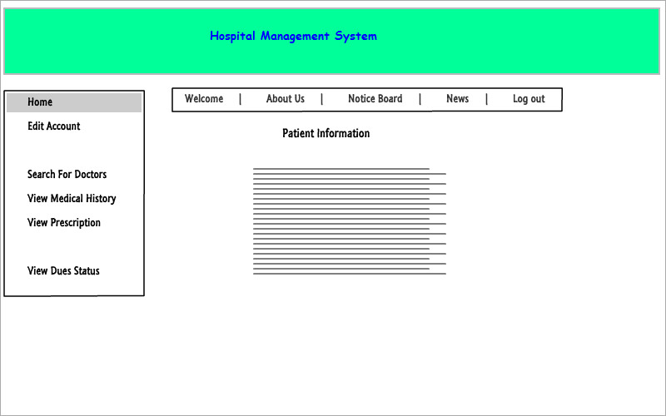

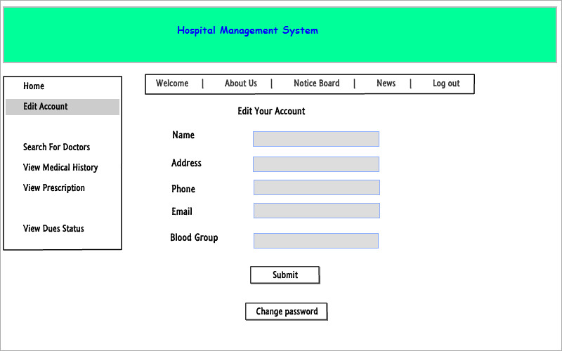

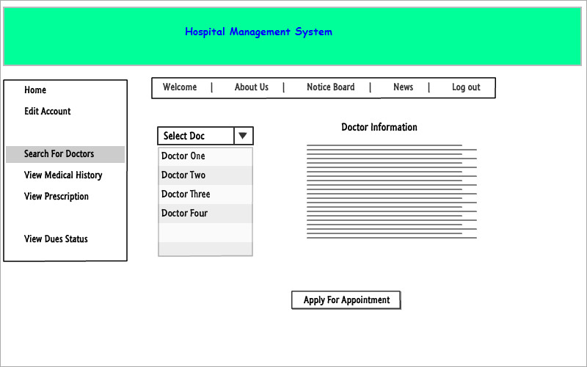

6.3 User Interface for Doctor:

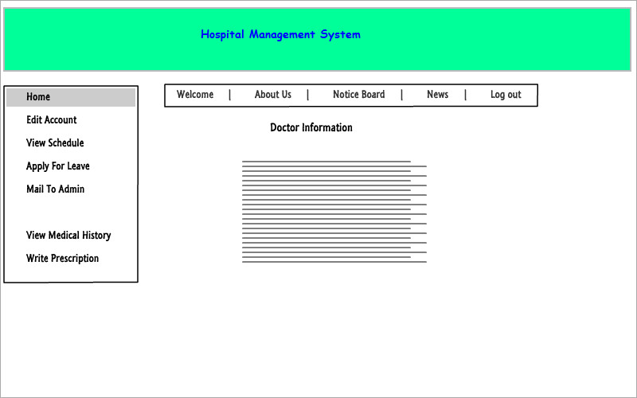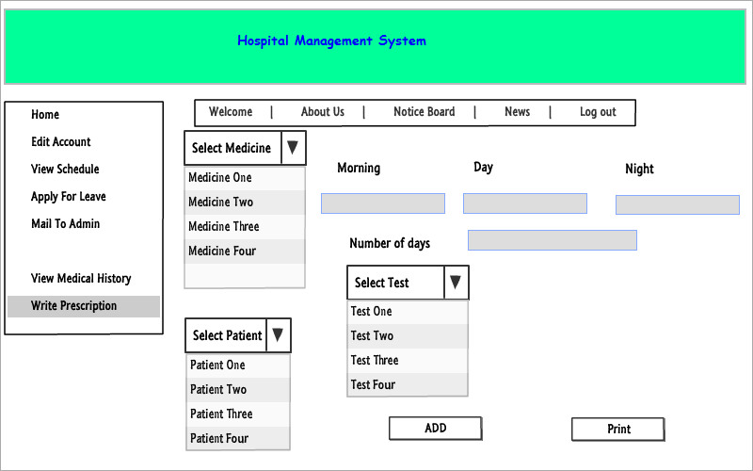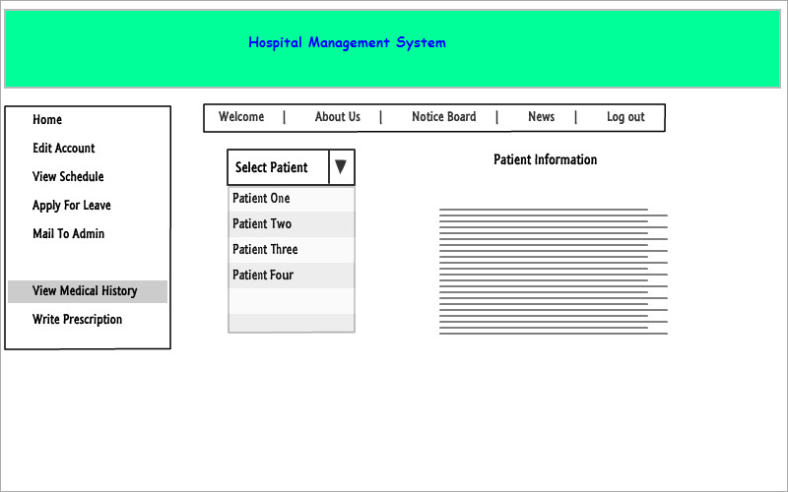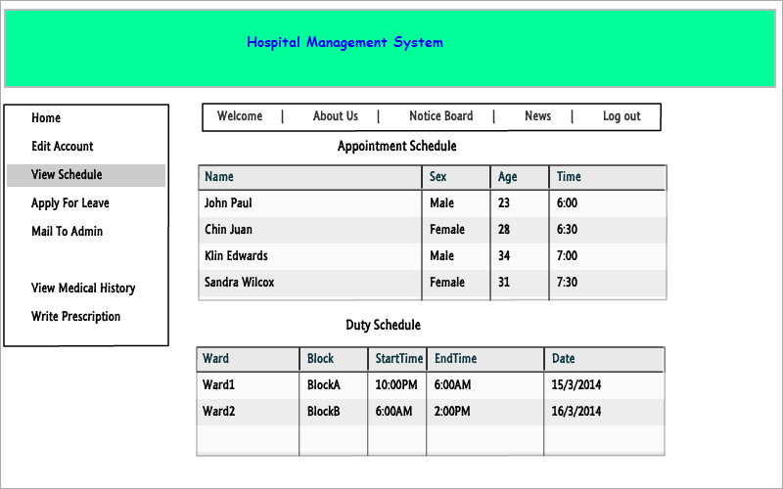

6.4 User Interface for Admin: 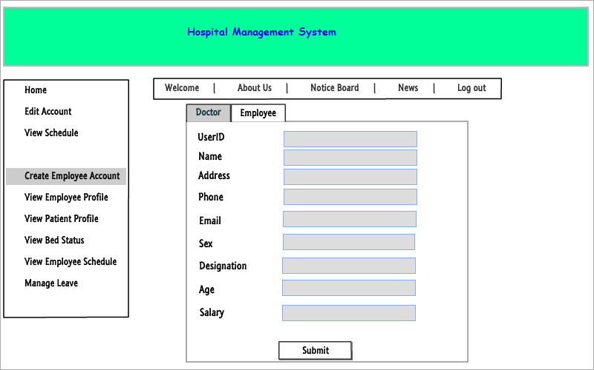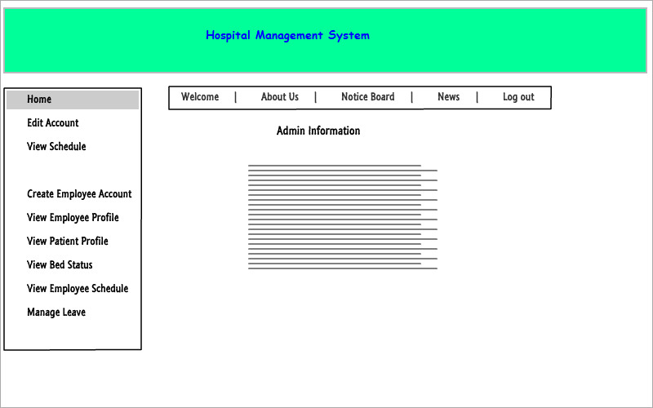 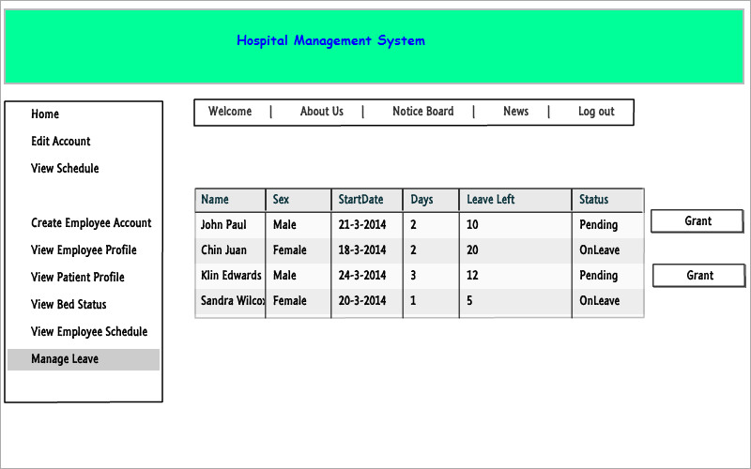

6.5 User Interface for Receptionist:

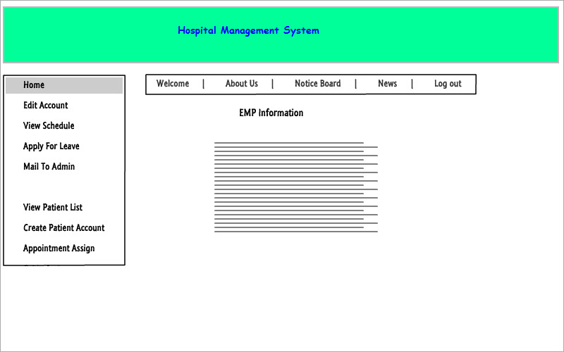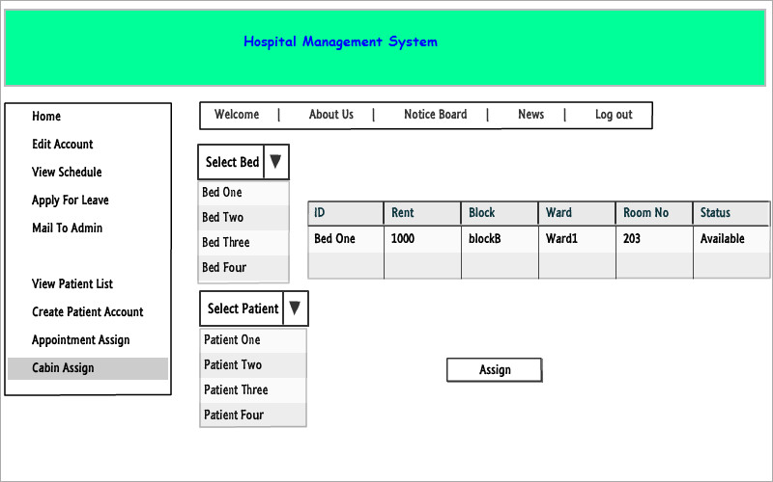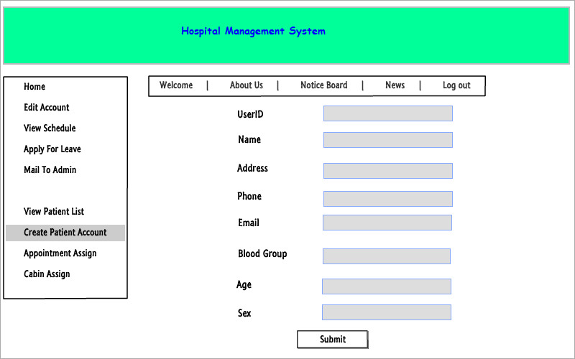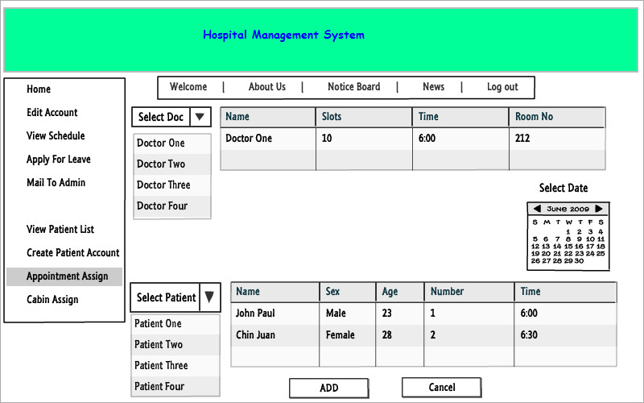

6.6 User Interface for Data Entry Manager:

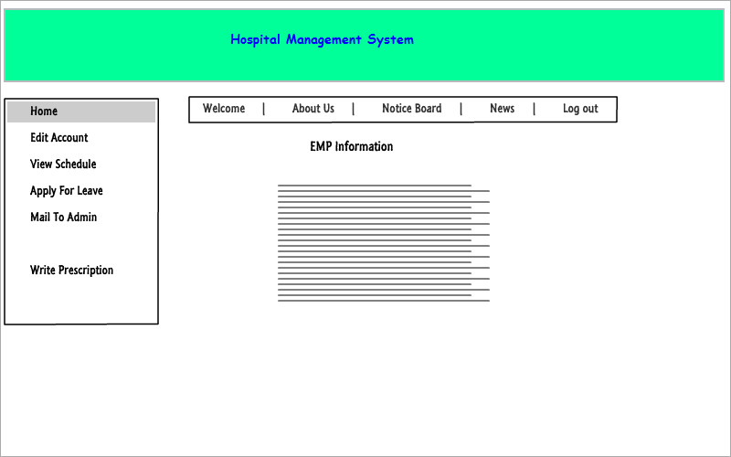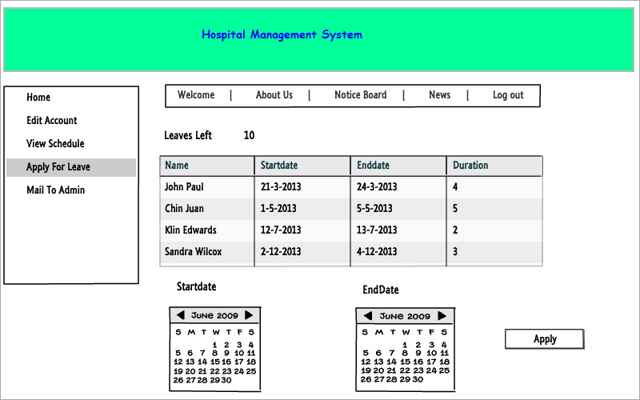

6.7 User Interface for Human Resource Officer :

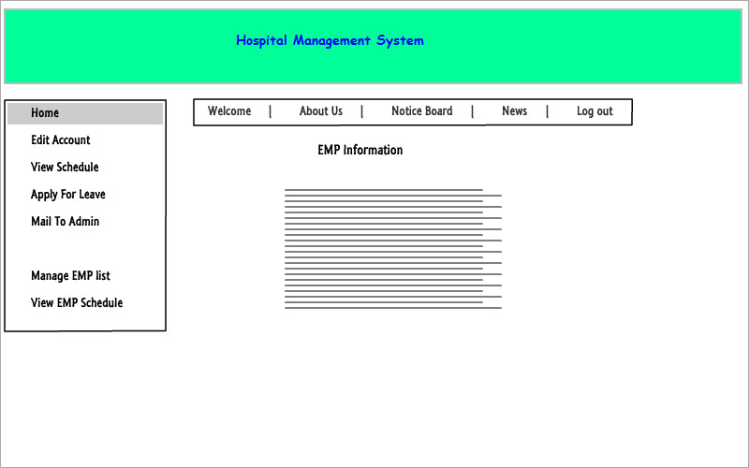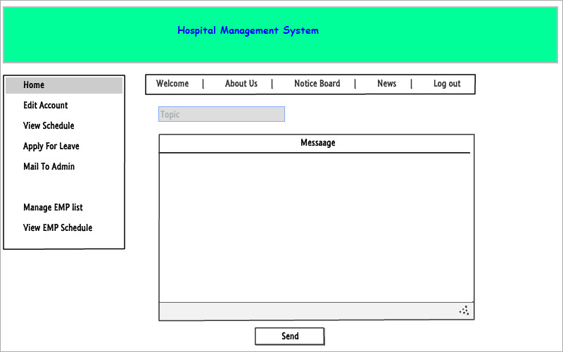

6.8 User Interface for Clerk: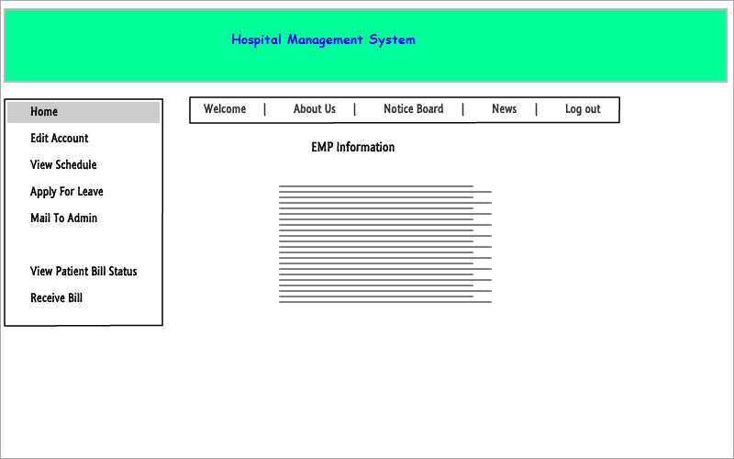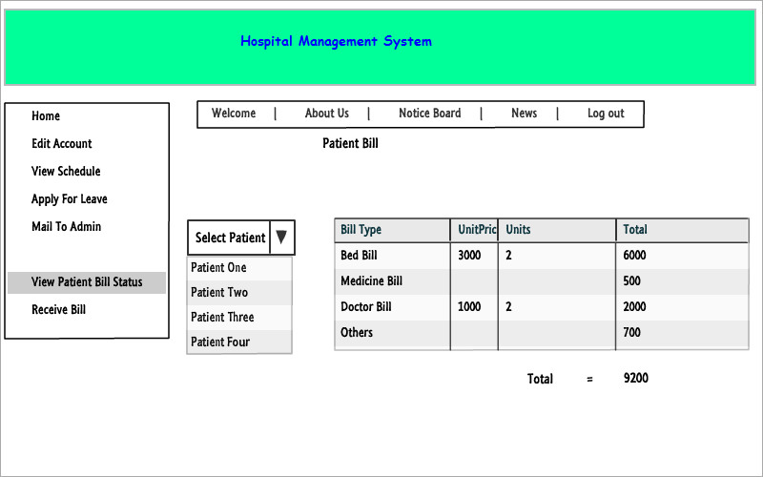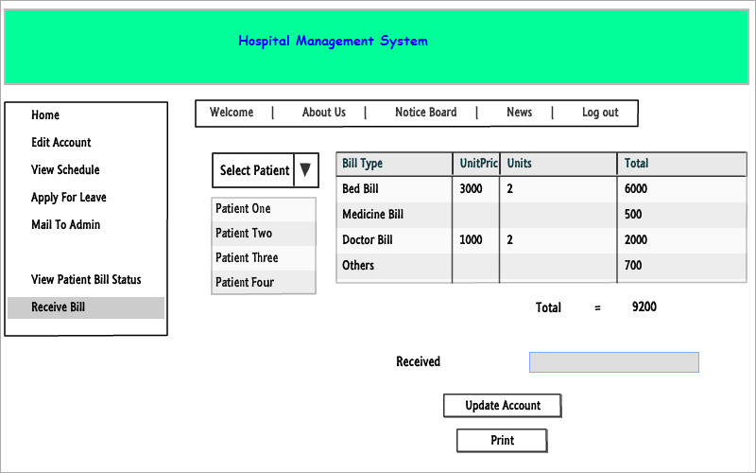

# 7. Project Management

The total management of the project consists of three phases:

1. Project planning
2. Project scheduling
3. Cost Benefit Analysis
4. Risk management

## 7.1 Project Phases and Activities

|  |  |
| --- | --- |
| Phases | Activities |
| System Analysis Phase | * Study of the existing system   i ) Study of the system architecture  ii) Scope definition   * Requirement analysis   i ) Stakeholder identification  ii) Problem discovery and analysis   * Feasibility analysis |
| Design Phase | * E-R diagram design * Input Output design |
| Implementation Phase | * Make Prototype * Make Total system |
| Testing Phase | * Component testing * System testing * Defect testing |

## 7.2 Project Scheduling Phases

Project scheduling done in four steps:

* + - 1. Task duration and dependencies
      2. Activity network
      3. Activity timeline
      4. Pert Chart

### 7.2.1 Task Duration & Dependency List



### 7.2.2 Activity Network



### 7.2.3 Pert Chart

The critical paths are shown here with darker line.



## 7.3 Cost Benefit Analysis:

Cost

1. Software Development Cost
2. New Hardware and Software
3. Expenses for training
4. Annual Cost

**Software Development Cost:**

|  |  |  |  |
| --- | --- | --- | --- |
| **Number** | **Type of Employee** | **Estimated work time & pay rate** | **Cost** |
| 2 | System Architect & Analysts | 50hours(400tk/hr) | 40000tk |
| 2 | GUI Designer and Programmer | 100hours(350tk/hr) | 70000tk |
| 1 | Database Specialist &System Librarian | 50hours(300tk/hr) | 15000tk |
| 5 | Total |  | 1,25,000 tk |

**New Hardware and Software:­**

|  |  |  |  |
| --- | --- | --- | --- |
| **Number** | **Type** | **Per unit cost** | **Cost** |
| 1 | Development Server | 5000tk | 5000tk |
| 1 | Server Software & hosting | 10000tk | 10000tk |
| 1 | DBMS server | 4000tk | 4000tk |
| 2 | DBMS client hosting | 6000tk | 12000tk |
| 35 | Desktop Computer | 25000tk | 8,75,000tk |
| 3 | Printer | 15000tk | 45000tk |
|  | Wires and Other equipments | 7000tk | 7000tk |
|  | Total |  | 10,00,000 tk |

**Expenses for training:**

|  |  |  |  |  |
| --- | --- | --- | --- | --- |
| **Number** | **Type of Trainee** | **Duration** | **package** | **Cost** |
| **20** | **Doctor** | **3 hours** | **2000tk** | **40000** |
| **10** | **Clerk** | **4 hours** | **1500tk** | **15000** |
| **15** | **Receptionist** | **5 hours** | **2000tk** | **30000** |
| **3** | **Data Entry Manager** | **8 hours** | **4000tk** | **12000** |
| **48** |  | **Total** |  | **97,000 tk** |

**Annual Cost**

|  |  |  |
| --- | --- | --- |
| **Number** | **Designation** | **Cost** |
| 2 | System Administrator | 2,40,000tk |
| 1 | Database programmer | 1,80,000tk |
| 1 | IT specialist(part time) | 1,00,000tk |
| 1 | Maintenance Agreement server | 5000tk |
| 1 | Maintenance Agreement DBMS server | 10000tk |
| 6 | Total | 5,35,000tk |

**Subscription Cost:**

1. Subscription cost will be 1,00,000tk per year.
2. With this much money the hospital will be able to use this system and have after sales service and maintenance every year.

Tangible Benefits :

1. Saves 1,50,000 tk per year due to having less employee.
2. Saves money due to purchase of less paper.
3. Reduces patient hassle.
4. Reduces 70% administrative work.
5. Increases employee performance.

**Intangible Benefits:**

1. Saves patients time
2. Work is made easier and accurate
3. Better care from doctor.
4. Good wishes of patients and their families

## 7.4 Risk Management

Risk occurs in two phases of a software development process. They are

1. During implementation
2. During upgrading and maintenance

Risk management is done in four steps. Steps are

* 1. Risk identification
  2. Risk analysis
  3. Risk planning
  4. Risk monitoring

At first, risks during implementation and then risk during upgrading and maintenance will be discussed.

Risks During Implementation

Implementation risks can be classified into two types.

* Long term implementation risk
* Short term implementation risk

Long term implementation risks

|  |  |  |
| --- | --- | --- |
| Risk | Category | Type |
| Staff turnover | Project | Technology |
| Unskilled Staff | Project | Technology |
| Management change | Project | Organizational |
| Requirement change  CASE tool inefficient | Project and product | Requirement  Tool |
| Technological Change | Business | Technology |
| Software component underperformance | Project and product | Technology |
| Organization restructured | Project and product | Organization |
| Organization Financial problem | Project and product | Organization |
| Time underestimate | Project and product | Requirement |
| Customer can’t understand impact of requirement change | Project | Requirement |
| Lost Funding | Project | Requirement |

Short term implementation risks

|  |  |  |
| --- | --- | --- |
| Risk | Category | Type |
| Staff unavailability | Project | People |
| Unavailable Stuff Training | Project and product | People |
| Hardware unavailability | Project | Technology |
| Specification delays | Project and product | Organization |
| Size Underestimate | Project and product | Estimation |
| Product Competition | Business | Technology |
| CASE Tool not integral | Product | Tool |

Risks during upgrading and maintenance

|  |  |  |
| --- | --- | --- |
| Risk | Category | Type |
| Database Under performance | Product | Technology |
| Defect repair rate underestimate | Product | Estimation |
| Large number of user than planned | Project and product | Estimation |
| Less reuse than plan | Project | Estimation |
| End user resist system | Business | Organization |

After risk identification, there comes risk analysis. Identified risks are analyzed below in descending order of their impacts.

Short term risk analysis

|  |  |  |  |  |  |
| --- | --- | --- | --- | --- | --- |
| Risk | Category | Type | Probability | Impact | Description |
| Product competition | Business | Organizational | Moderate | Catastrophic | A competitive product is marketed before the system is completed. |
| Specification delays | Project and product | Organizational | High | Serious | Specification of essential interfaces is not available on schedule. |
| Staff unavailability | Project | Technology | Moderate | Serious | Key staff is ill and unavailable at critical times. |
| CASE tool un integrable | Product | Tool | High | Tolerable | CASE tool can’t be integrated. |
| Hardware unavailability | Project | Technology | High | Tolerable | Hardware essential for the project will not be delivered on schedule. |
| Unavailable staff training | Project and product | People | Moderate | Tolerable | Required training for staff is not available. |
| Unavailable staff training | Project and product | People | Moderate | Tolerable | Required training for staff is not available. |
| Size underestimate | Project and product | Estimation | High | Tolerable | The size of the system has been underestimated. |

Long term risk analysis

|  |  |  |  |  |  |
| --- | --- | --- | --- | --- | --- |
| Risk | Category | Type | Probability | Effect | Description |
| Unskilled staff | Project | Technology | High | Catastrophic | Required training for staff is not available. |
| Organization financial problem | Project and product | Organizational | Low | Catastrophic | This problem forces reductions in the project budget. |
| Lost funding | Project | Requirement | Low | Catastrophic | Funding will be lost. |
| Management change | Project | Organizational | Low | Catastrophic | There will be a change of organizational management with different priorities. |
| Requirement change | Project and product | Requirement | Moderate | Serious | There will be a large number of changes to the requirements than anticipated. |
| Software component underperformance | Project and product | Technology | Moderate | Serious | Software component that should be reused contain defects which limit their functionality. |
| Organization restructured | Project and product | Organizational | High | Serious | The organization is restructured so that different management is responsible. |
| Time underestimate | Project and product | Estimation | High | Serious | The time re quired to develop the software is underestimated. |
| Time underestimate | Project and product | Estimation | High | Serious | The time re quired to develop the software is underestimated. |
| Staff turnover | Project | Technology | Moderate | Serious | Experienced staff will leave the project before it is finished. |
| Technology change | Business | Technology | Moderate | Tolerable | The underlying technology on which the system is built is superseded by new technology. |
| Customer can’t understand impact of requirement change | Project | Requirement | Moderate | Tolerable | Customers fail to understand the impact of requirement changes. |
| CASE tool inefficient | Product | Tool | Moderate | Insignificant | The code generated by CASE tools is inefficient. |

Analysis of upgrading and maintenance risks

|  |  |  |  |
| --- | --- | --- | --- |
| Risk | Probability | Effect | Description |
| Large number of user than planned | Project and product | Estimation | Moderate |
| Database underperformance | Product | Technology | Moderate |
| Defect repair rate underestimate | Project | Estimation | Moderate |
| Less reuse than planned | Project | Estimation | Low |
| End user resist system | Business | Organizational | Low |

As there are a number of risks present in the system. So, a strategy is developed for overcoming risk effects.

Risk Planning

|  |  |
| --- | --- |
| Risk | Strategy |
| Staff Turnover | * Meet with current staff to determine causes. * Mitigate those causes that are under our control before project starts. * Once the project starts assume turnover will occur. * So to ensure continuity when people leave, conduct a team meeting after every week so that everyone can know other’s project update. * Conduct peer review of all work. * Assign a backup staff member for every critical technology. |
| Organizational financial problems | Prepare a briefing document for senior management showing how the project is making very important contribution to the goals of the business. |
| Recruitment problems | Alert customers of potential difficulties and the possibility of delays investigate buying-in components. |
| Product Competition | User interface, functionality and options are to be designed such a way that it can compete easily in the market. |
| Unavailable staff training | Prepare staff training for a small schedule so that proper utilization of time happens. |
| Size underestimate | Back up plan for all software developments will work at this point. |
| Staff turnover | We can assume this vulnerable risk won’t happen in the software project. If happens, schedule must be expanded from the client. |

Risk Monitoring

Risk monitoring involves regularly assessing each of the identified risks. As this cannot usually be observed directly so we have to look at other factors .These factors are described here.

|  |  |
| --- | --- |
| Risk Type | Potential Indicator |
| Technology | * Late delivery of hardware or support software * Many repotted technology problems. |
| People | * Poor staff moral, * Poor relationships amongst team members , * Job availability |
| Organizational | * Organizational gossip , * Lack of action by senior management. |
| Tools | * Reluctance by team members to use tools , * Complaints about case tools , * Demands for higher powered work stations. |
| Requirements | * Many requirements change requests * Customer complaints. |
| Estimation | * Failure to meet agreed schedule , * Failure to clear reported defects |

Risk monitoring is a continuous process. The following cycle reflects the monitoring plan.

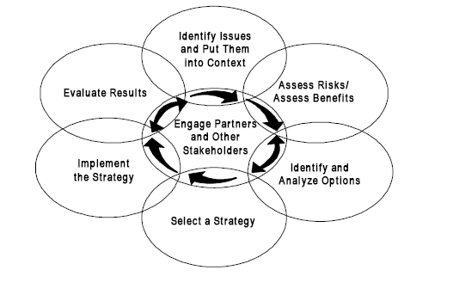

Fig: Risk monitoring system

Calculating Risk Exposure (RE)

The RE of a risk is determined by the law

RE = P*C

Here P=probability of occurrence

C=cost to the project risk should occur

Now for the risk of software component underperformance the risk is calculated as:

P=60%=.60

We assume that there will be 15 components; each having 200 lines of codes (LOC) and cost for each LOC is 15 tk.

So here C=15*200*15=45,000

So, RE = .6*45000

= 27,000 tk

The RE for other risks are also calculated like above.

The Sheets of Risk Information

This sheet reflects the details of the risk maintenance and monitoring. From all of our identified risk we have found the sheet of risk information for two risks.

1. Software component under performance
2. Staff turn over

For Software component underperformance

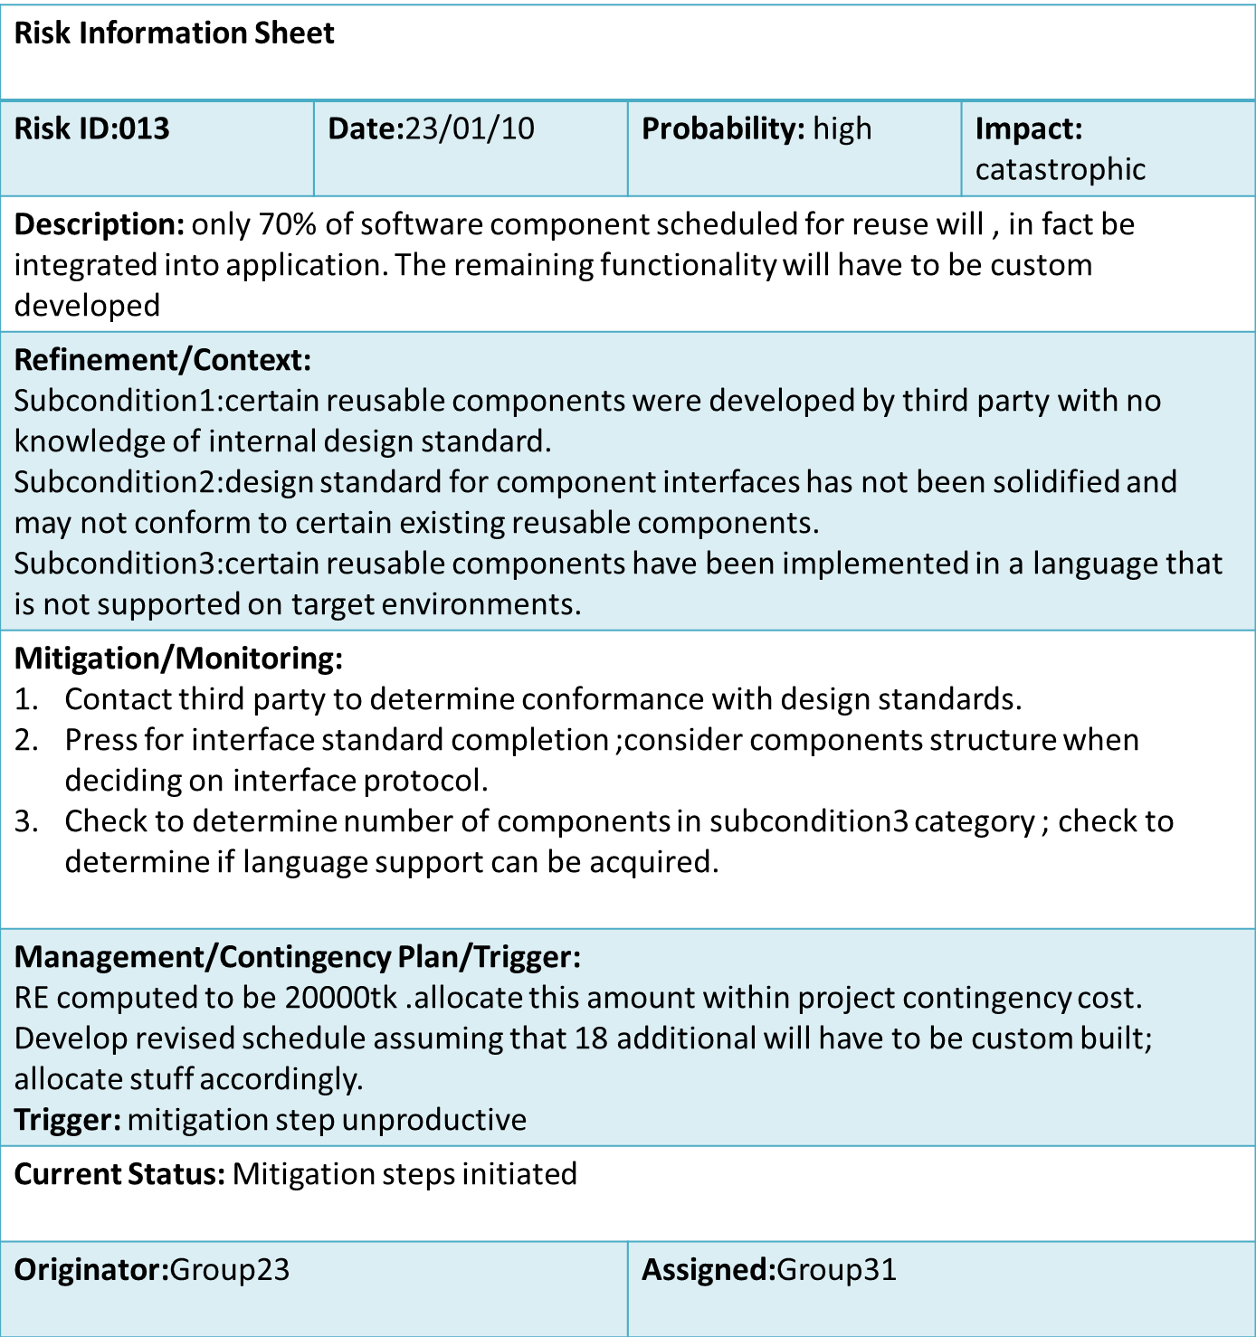

For staff turn over

